A Project Report On

**“**Plant Disease Prediction Using Deep Learning**.”**

Submitted in partial fulfillment of the Requirements for the award of the

Degree of

**BACHELOR OF SCIENCE (COMPUTER SCIENCE)**

**SEM VI Examination**

Submitted by

**Surajkumar Yadav**

**ROLL NUMBER: 2225509**

Under the esteemed guidance of:

**Prof. Shreya Tiwari**

Assistant Professor



**DEPARTMENT OF COMPUTER SCIENCE**

**SEVA SADAN’s R. K. Talreja College**

**of Arts, Science and Commerce,**

**Ulhasnagar-421 003**

**(*Affiliated to University of Mumbai*)**

**A.C. 2022-2023**

**Seva Sadan's R.K.Talreja College of Arts, Science &Commerce**

***(Affiliated to University of Mumbai)***

**Maharashtra, Ulhasnagar - 421003**

**DEPARTMENT OF COMPUTER SCIENCE**



**CERTIFICATE**

This is to certify that the project entitled, **"**Plant Disease Prediction Using Deep Learning **"**, is bonafied work of **Surajkumar Yadav** bearing Seat.No: **(2225509)** submitted in partial fulfillment of the requirements for the award of degree of BACHELOR OF SCIENCE in COMPUTER SCIENCE from University of Mumbai.

**Internal Guide Coordinator**

**External Examiner**

**Date: College Seal**

**ABSTRACT**

The project "Plant Disease Prediction using Deep Learning" aims to develop a system that can accurately identify various diseases in plants using machine learning algorithms. The system will be trained on a dataset of images of plants affected by different diseases and will use deep learning techniques to extract relevant features from the images. The extracted features will then be used to train a model that can classify new images of plants based on the presence or absence of disease. The project will involve the use of deep learning frameworks such as TensorFlow, Keras, and will require the use of image processing techniques such as convolutional neural networks (CNNs) and transfer learning. Other technologies that are used to built the webapps are React JS , Streamlit, javascript. The data used had thousands of images of various plant diseases in a very organized manner.

The project involves training a deep learning model using a large dataset of images of healthy and diseased plants to learn and recognize patterns that distinguish between the two. The trained model is then used to classify new images of plants as healthy or diseased, enabling early detection and effective treatment of plant diseases.

The ultimate goal of the project is to provide a tool that can help farmers and plant pathologists quickly identify and treat plant diseases, leading to higher crop yields and better food security.

**Acknowledgment**

It is a genuine pleasure to express my profound gratitude and deep regards to my guide **" Prof. Shreya Tiwari"** for her exemplary guidance, monitoring and constant encouragement. I would like to express my special thanks to the computer science department from my college who gave me the golden opportunity to do this wonderful project on the topic " Plant Disease Prediction Using Deep Learning", which helped me in doing a lot of Research and I came to know about so many new things.

We are also thankful to all of our teachers of the department who helped us in a number of ways by providing various resources and moral support. Last of all we are grateful to our family, who are, always with us in our every step of life.

# TABLE OF CONTENTS

# 

# 

**CHAPTER 1 ----------------------------------------------------------------------- 6**

**1.Introduction, purpose, Existing system,**

**Proposed system, Deep Learning, CNN,**

**Transfer Learning. ----------------------------------------------------- 6-16**

**CHAPTER 2 ----------------------------------------------------------------------- 17**

**2.Project background, User requirement, user of system, Requirement analysis, SDLC, Agile model, design, phase,**

**A&D --------------------------------------------------------------------- 17-25**

**CHAPTER 3 ------------------------------------------------------------------- 26**

**3.System Analysis, UML diagrams -------------------------------- 20-24**

**CHAPTER 4 ------------------------------------------------------------------- 25**

**4.Database structure, Snapshots ----------------------------------- 25-39**

**CHAPTER 5 ------------------------------------------------------------------- 40**

**5.System code, Limitation, Future scope ------------------------- 40-48**

**REFERENCE ------------------------------------------------------------------ 49**

# CHAPTER 1

# INTRODUCTION

Plant diseases can have a significant impact on crop yield and quality, resulting in financial losses for farmers and potentially affecting global food security. Early detection and accurate diagnosis of plant diseases are crucial for effective management and control of plant diseases. The use of deep learning algorithms in plant disease prediction offers a promising solution to this problem.

The Plant Disease prediction using Deep Learning project aims to develop an accurate and reliable system for early detection and diagnosis of plant diseases using machine learning techniques. The project involves the use of deep learning algorithms to analyze large datasets of images of healthy and diseased plants to identify patterns that distinguish between the two.

The deep learning model is trained to recognize visual cues and patterns associated with different types of plant diseases. Once the model is trained, it can be used to classify new images of plants and accurately identify the presence of any diseases.

The benefits of this project are significant, as early detection of plant diseases can help farmers take preventive measures and reduce the spread of diseases, leading to increased crop yields and reduced financial losses. Moreover, the system can help farmers make informed decisions about crop management, including the use of pesticides and fertilizers, thus reducing costs and minimizing environmental damage.

In summary, the Plant Disease prediction using Deep Learning project offers a promising solution to the challenge of early detection and diagnosis of plant diseases, with significant potential benefits for farmers and the agriculture industry as a whole.

* 1. **Purpose of the project.**

# The world is changing very rapidly with Artificial Intelligence and other technological advances that are making the human more comfortable and easier.

# Our application aims the same to automate the recognition process of Diseases in plants and provide treatment . The purpose of the Plant Disease prediction using Deep Learning project is to develop a reliable and accurate system for early detection and diagnosis of plant diseases using machine learning techniques. The project aims to leverage the power of deep learning algorithms to analyze large datasets of images of healthy and diseased plants and identify patterns that can distinguish between the two.

# The project's primary objective is to improve crop yield and quality while reducing financial losses caused by plant diseases. By detecting and diagnosing plant diseases at an early stage, the project can help farmers take preventive measures and reduce the spread of diseases, leading to increased crop yields and reduced financial losses.

* 1. **Existing System**

In the present system all work is done manually by checking the condition of plants in a field which requires accurate knowledge of the checker preferably a Doctor or a Biologist. The system is very time consuming and requires a lot of human labour. A major drawback is to keep the records of diseased plants and the way to treat it and also a large amount of time gets passed from checking and treating the plants which may worsen the condition of the plants.

**Traditional systems used for disease prediction in plants have several weaknesses, including:**

● Reliance on Visual Symptoms: Traditional disease prediction systems often rely on visual symptoms to diagnose plant diseases, which can be unreliable and subject to interpretation. Visual symptoms can also be difficult to detect in the early stages of disease, leading to delays in treatment and a higher risk of crop loss.

● Lack of Data Integration: Traditional disease prediction systems often do not integrate data from multiple sources, such as weather data or soil conditions, which can affect disease development. This can limit their accuracy and reliability, as they may fail to account for all the factors that contribute to disease outbreaks.

● Limited Flexibility: Traditional disease prediction systems are often inflexible, as they are designed to detect specific diseases or pests. This can make it difficult to adapt to new diseases or changing environmental conditions, leading to delays in response and potentially higher crop losses.

# ● High Cost: Many traditional disease prediction systems are costly to implement, as they require specialized equipment or expertise. This can make them inaccessible to small-scale farmers or those in developing countries, limiting their usefulness in areas where plant diseases are a significant threat to crop yield and food security.

# Overall, the weaknesses of traditional disease prediction systems highlight the need for more advanced and flexible systems that can integrate data from multiple sources and accurately predict and diagnose plant diseases. The use of technologies such as deep learning and machine learning offers promising solutions to these challenges.

**1.3 Proposed system**

To overcome the drawbacks of the existing system, the proposed system has been evolved. This project aims to reduce the manual work and saving time to generate accurate results of plant Diseases. The system provides with the best user interface.

**Advantages of Proposed System:**

* It is trouble-free to use.
* It is a relatively fast approach to Predict Diseased plants.
* Is highly reliable, approximate result most of the times.
* Best user Interface
* Availability.

※ There are 2 different systems that I am proposing:

1. **A React JS web App**:

This app runs locally on a device with FastAPI as backend and React JS as frontend. The deep learning model is stored as .h5 file and is called by fastapi on localhost which is used on frontend for predictions. The frontend includes a basic structure of an app which has a input parameter for images where we have to upload the plants leaves images which is sent to the backend.

1. **A Streamlit Web app hosted on cloud:**

This app is fully functional web app accessible from anywhere in the world and uses Streamlit as frontend and Google Cloud Platforms [Cloud Functions] as Backend. The following modules are there in the app:

1. **Admin Login Module:** This module is for logging into the system and accessing all the services with proper credentials, You can signup by using the signup button and if you forget your password or username there are options to retrieve it .
2. **Predict Disease Module:** This is the module where you upload you plants image to get the results, there are two options either you can upload a file from your device or you can click an image from the devices camera.
3. **Disease Information module:** This module is where you can find all the information about different Diseases that affect the plants and how to identify them and treat them.

**Theory:**

* **DEEP Learning:**

Deep learning is a type of machine learning that involves the use of neural networks with many layers, also called deep neural networks. These networks can learn to recognize complex patterns and relationships in data, making them well-suited for tasks such as image recognition, speech recognition, natural language processing, and more.

The main advantage of deep learning over traditional machine learning methods is its ability to automatically learn feature representations from raw data. This eliminates the need for manual feature engineering, which can be time-consuming and require expert knowledge.

Deep learning models are typically trained using large datasets, and the learning process involves adjusting the weights and biases of the network in response to input data. This is done using an optimization algorithm such as stochastic gradient descent, which minimizes the error between the network's predicted output and the actual output.

Some popular types of deep learning models include convolutional neural networks (CNNs), which are commonly used for image and video processing; recurrent neural networks (RNNs), which are suited for sequential data such as time series or natural language processing; and generative adversarial networks (GANs), which can be used for generating new data based on existing datasets.

Despite their effectiveness, deep learning models can be computationally intensive and require significant computational resources. However, advances in hardware and software have made deep learning more accessible and easier to use for a wide range of applications.

* **Convolution Neural Network:**

A neuron is a basic unit of a neural network, which is inspired by the structure and function of the human brain. A neuron receives input from other neurons or sensors, performs a computation, and produces an output that can be sent to other neurons or to an external system. The computation performed by a neuron involves a weighted sum of its inputs, followed by the application of an activation function. The weights determine the contribution of each input to the output, and they are adjusted during the learning process to optimize the performance of the network.

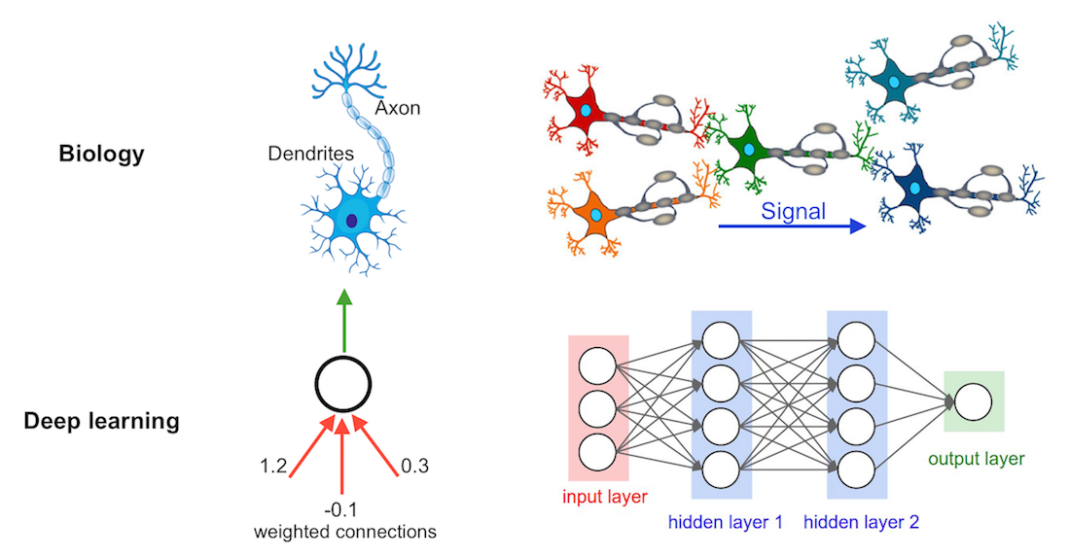

A neural network is a collection of interconnected neurons organized in layers. The input layer receives input from the external world, and the output layer produces the final output of the network. Between the input and output layers, there can be one or more hidden layers, each composed of multiple neurons. The neurons in one layer are connected to the neurons in the next layer, forming a directed graph. Neural networks can be trained using supervised or unsupervised learning methods. In supervised learning, the network is presented with input-output pairs, and the weights are adjusted to minimize the error between the predicted and actual outputs. In unsupervised learning, the network learns to represent the input data without explicit labels.

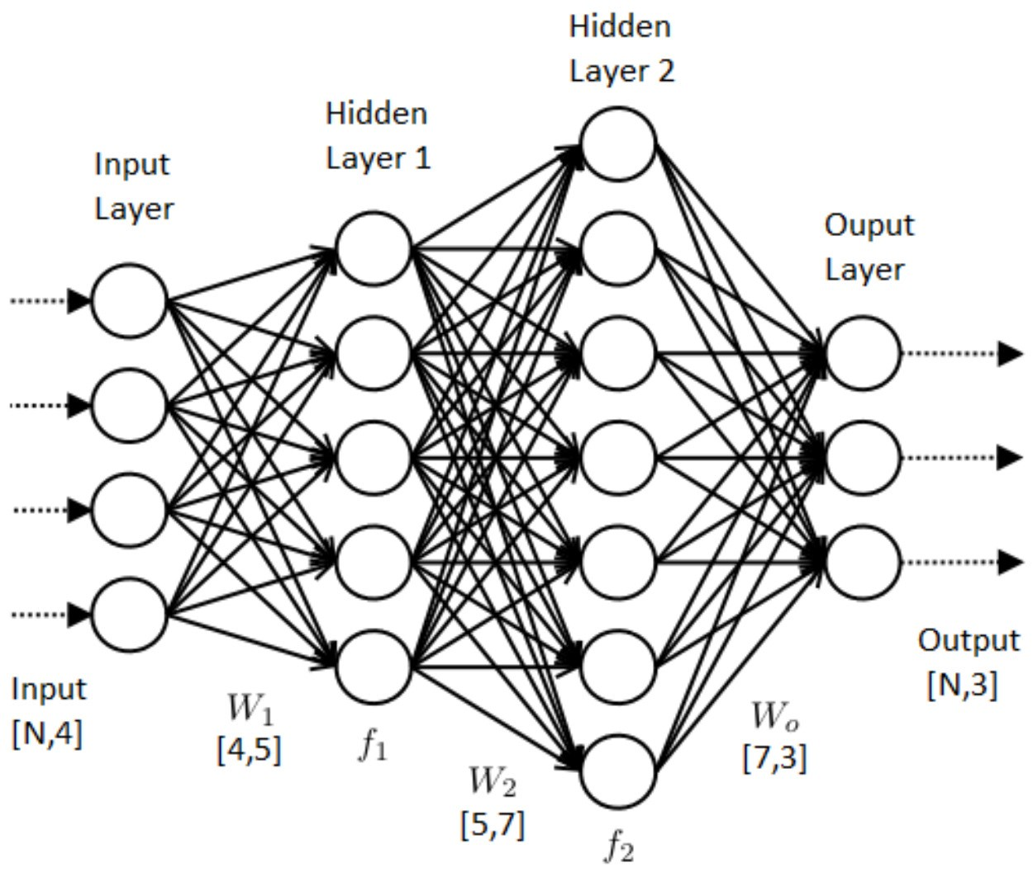

Convolutional neural networks (CNNs) are a specialized type of neural network that is commonly used for image and video processing tasks. CNNs use convolutional layers to extract features from the input images, and pooling layers to reduce the dimensionality of the features. The output of the convolutional and pooling layers is flattened and fed into a fully connected layer that produces the final output. The convolutional layers in a CNN are designed to be translation-invariant, meaning that they can recognize patterns in different parts of the image regardless of their location. CNNs are often used in applications such as image classification, object detection, and facial recognition. They have achieved state-of-the-art performance on many benchmark datasets and are widely used in industry and academia.



* **Transfer learning:**

Transfer learning is a technique in machine learning and deep learning where a pre-trained model is used as a starting point for a new task. Instead of starting from scratch and training a new model on a large dataset, transfer learning allows us to leverage the knowledge and feature representations learned by a pre-trained model on a related task. The idea behind transfer learning is that many real-world problems share some common underlying structure or features, and a model that has learned these features on a related task can be adapted to a new task with less data and computation.

There are two main approaches to transfer learning: fine-tuning and feature extraction. In fine-tuning, we start with a pre-trained model and train it on the new task using a small amount of new data. We typically freeze most of the layers of the pre-trained model and only fine-tune the last few layers that are specific to the new task. This allows us to leverage the general feature representations learned by the pre-trained model while adapting to the specific characteristics of the new task. In feature extraction, we use the pre-trained model as a fixed feature extractor and train a new classifier on top of the extracted features. We typically remove the last few layers of the pre-trained model and use the output of the remaining layers as features for the new task. This approach is particularly useful when we have limited data for the new task or when the pre-trained model is too large to be fine-tuned on a new task.

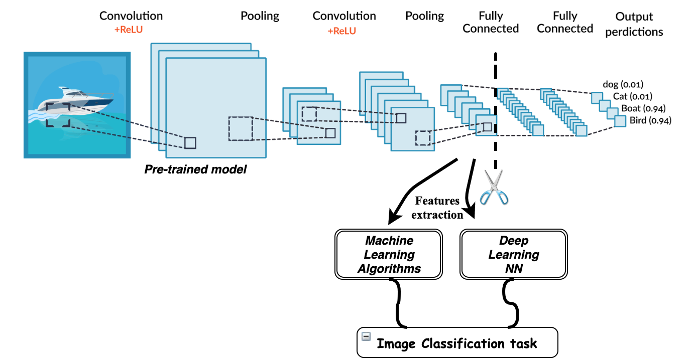

Transfer learning has been shown to be effective in a wide range of applications, including computer vision, natural language processing, and speech recognition. It can significantly reduce the time and resources required to train a new model and improve the performance of the model on the new task. Pre-trained models such as VGG, ResNet, and BERT are widely used as starting points for transfer learning, and many open-source libraries provide pre-trained models and tools for fine-tuning and feature extraction.

# CHAPTER 2

# REQUIREMENT SPECIFICATION AND ANALYSIS PHASE

* 1. **Project Background**

# The background for disease prediction in plants lies in the significant impact that plant diseases have on agricultural productivity, food security, and economic stability worldwide. Plant diseases can cause crop losses, reduce crop quality, increase production costs, and damage the environment. They can also pose a threat to human health, as some plant diseases can be transmitted to humans through contaminated food.

# In the past, plant diseases were primarily managed through the use of chemical pesticides and fungicides. However, the overuse of these chemicals has led to resistance in plant pathogens and environmental damage, creating the need for more sustainable and effective disease management strategies.

# Recent advances in computer vision, machine learning, and deep learning offer promising solutions for detecting and predicting plant diseases in a more accurate and timely manner. By analyzing large datasets of images of healthy and diseased plants, these technologies can identify patterns and features that are indicative of disease, allowing for early detection and diagnosis.

# The development of disease prediction models using deep learning algorithms has the potential to revolutionize plant disease management by providing farmers with early warning systems that can help them take preventive measures and reduce the spread of diseases. This can lead to increased crop yields, reduced costs, and improved environmental sustainability.

**2.2 User Requirements**

To deliver the best service to the users we tried to find out the user’s necessities which are below:

**Administrator Aspect:**

* Monitoring the whole system from the admin panel.
* Taking backup of the database.
* Creating, deleting and modifying the records.
* Add entities for the admin panel.
* Keeping the entities record like their details.

**Users Aspect:**

* **Getting smooth functionality and performance of the app.**
* **Getting to know the record of disease plants.**
* **Saving their time.**

**2.4 Requirement Analysis**

The **Plant Disease prediction using Deep Learning** is a web based application. The main purpose of the project is to provide a convenient and easy way for a farmer to identify and treat diseased plants. To develop this System. Software and Hardware Requirements are necessary. Requirements which are needed are given below briefly.

**Hardware Requirements**:

**Processor**-At least 3.0 GHZ (greater than i3 intel processors).

**RAM**-At least 4GB.

**SSD would be great.**

**Your system must have camera for taking input.**

**Software Requirements:**

**Compatible operating system**: Windows 8 and higher, Linux, Mac.

**Front end design tool** -Streamlit (python), CSS, React JS.

**Back End**-FastApi, Google Cloud Platforms.

**Editor Tools** -Notepad++, Visula Studio Code, Anaconda.

**Web Browser**-Google Chrome, Firefox, or any compatible updated browser.

**Database tools**: GCP [Cloud Storage Bucket]

**2.5 Project Develop Languages**

The Main language used in developing the web application is Python and its various libraries such as :

* **Tensorflow and keras** for model building and testing.
* **streamlit** for frontend.
* **Requests** for working with the model deployed on the GCP as backend.
* **Pillow**  for image Manipulation.
* **Numpy**  for mathematical calculations.
* **Streamlit_authenticator** for authentication purposes.
* **Streamlit_extras** for enhancing the look of frontend.
* **time** for Time related aspects.

**2.6 Why Developers use python and its libraries :**

**Python:**

Python is a high-level, interpreted, and general-purpose dynamic programming language that focuses on code readability. It generally has small programs when compared to Java and C. It was founded in 1991 by developer Guido Van Rossum. Python ranks among the most popular and fastest-growing languages in the world. Python is a powerful, flexible, and easy-to-use language. In addition, the python community is very active. It is used in many organizations as it supports multiple programming paradigms. It also performs automatic memory management.

**Advantages:**

1 . Presence of third-party modules

2. Extensive support libraries (NumPy for numerical calculations, Pandas for data analytics,etc.)

3. Open source and large active community base

4. Versatile, Easy to read, learn and write

5. User-friendly data structures

6. High-level language

7. Dynamically typed language(No need to mention data type based on the value assigned, it takes data type).

**2.7 Software Development Life Cycle**

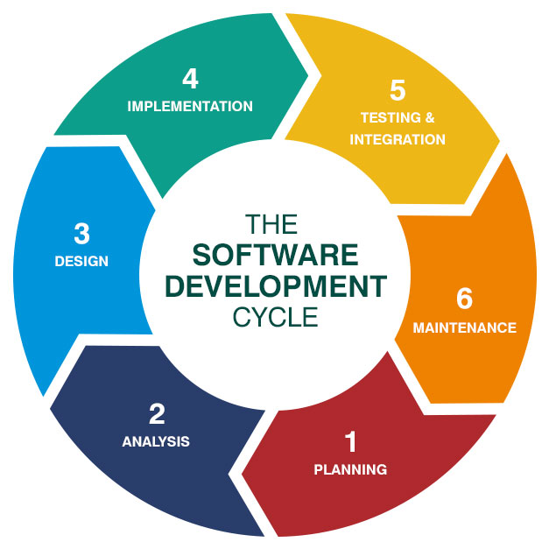

The software industry includes many different processes, for example, analysis, development, maintenance and publication of software. This industry also includes software services, such as training, documentation, and consulting. Our focus here is about software development life cycle (SDLC). So, due to that different types of projects have different requirements. Therefore, it may be required to choose the SDLC phases according to the specific needs of the project. These different requirements and needs give us various software development approaches to choose from during software implementation

**2.7.1. SDLC Models**

There are various software development life cycle models defined and designed which are followed during the software development process. These models are also referred to as "Software Development Process Models". Each process model follows a Series of steps unique to its type, in order to ensure success in the process of software development. Following are the most important and popular SDLC models followed in the industry :

1. Waterfall model

2. V-Shaped model

3. Prototyping model

4· Spiral model

5. Iterative and Incremental model

6. Agile model

7. RAD model.

**2.7.2 Agile model**:

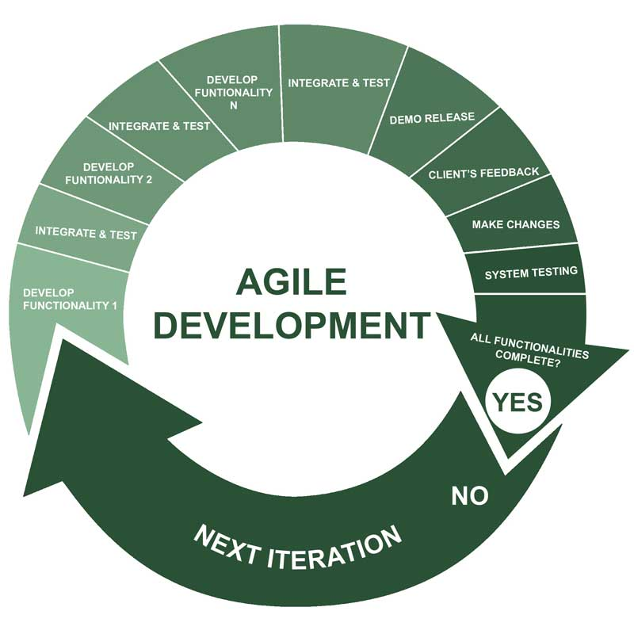

When it comes to data science projects, the Agile SDLC model is often considered the best fit. Here are some reasons why:

● **Flexibility:**

Data science projects are often exploratory in nature, with a high degree of uncertainty and risk involved. The Agile model is well-suited to this type of project as it allows for flexibility and adaptability throughout the development process. Teams can adjust their plans and priorities as they learn more about the problem domain, data, and model performance.

● **Iterative Development:**

The Agile model emphasizes iterative development and continuous improvement. This is particularly beneficial for data science projects, which require a lot of experimentation and fine-tuning to achieve optimal performance. The iterative approach allows for regular testing, evaluation, and feedback, enabling teams to refine their models and algorithms over time.

●**Cross-Functional Teams:**

Data science projects typically require collaboration between different teams, including data engineers, data scientists, and subject matter experts. The Agile model supports cross-functional teams, allowing for better communication and collaboration between team members with different skill sets.

**●Customer Collaboration**:

The Agile model emphasizes customer collaboration and feedback, ensuring that the end product meets the needs of the customer. For data science projects, this means involving subject matter experts and stakeholders in the development process to ensure that the models and algorithms are aligned with their needs and goals.

● **Short Timeframes**:

Data science projects often have short timeframes and tight deadlines, which can be challenging to manage using traditional SDLC models. The Agile model emphasizes rapid prototyping and delivery, allowing teams to deliver working models and algorithms quickly and frequently.

# Overall, the Agile SDLC model is well-suited to data science projects as it provides the flexibility, iterative development, cross-functional teams, customer collaboration, and short timeframes needed to develop effective and innovative solutions.

**2.7.3 PhasesAgile model**:

1. **Planning**: In this phase, the team defines the scope of the project, sets goals, and creates a roadmap for the development process. The team collaborates with the stakeholders to identify the requirements, prioritize them, and create a product backlog.
2. **Analysis**: In this phase, the team analyzes the requirements and creates user stories, which are short descriptions of the features and functionalities that the product should have. The team estimates the effort required for each user story and creates a sprint backlog, which is a list of user stories that will be addressed in the current sprint.
3. **Design**: In this phase, the team designs the architecture of the product, defines the technical requirements, and creates a plan for the implementation. The team collaborates with the stakeholders to ensure that the design meets their needs and expectations.
4. **Implementation**: In this phase, the team develops the product according to the plan and the sprint backlog. The team follows the Agile principles of collaboration, self-organization, and continuous improvement. The team delivers a working product at the end of each sprint, which is reviewed by the stakeholders.
5. **Testing**: In this phase, the team tests the product to ensure that it meets the quality standards and the user requirements. The team uses various testing techniques, such as unit testing, integration testing, and acceptance testing, to identify and fix defects.
6. **Deployment**: In this phase, the team deploys the product to the production environment and makes it available to the users. The team monitors the product and collects feedback from the users to improve the product in future sprints.
7. **Review and Retrospective**: In this phase, the team reviews the sprint and the product with the stakeholders, demonstrates the progress made, and collects feedback. The team also conducts a retrospective, where they reflect on the sprint and identify opportunities for improvement. The team uses the feedback and the retrospective to plan the next sprint and improve the process.

# CHAPTER 3

**SYSTEM DESIGN DETAILS/System Analysis**

**3.1 Component Diagram**

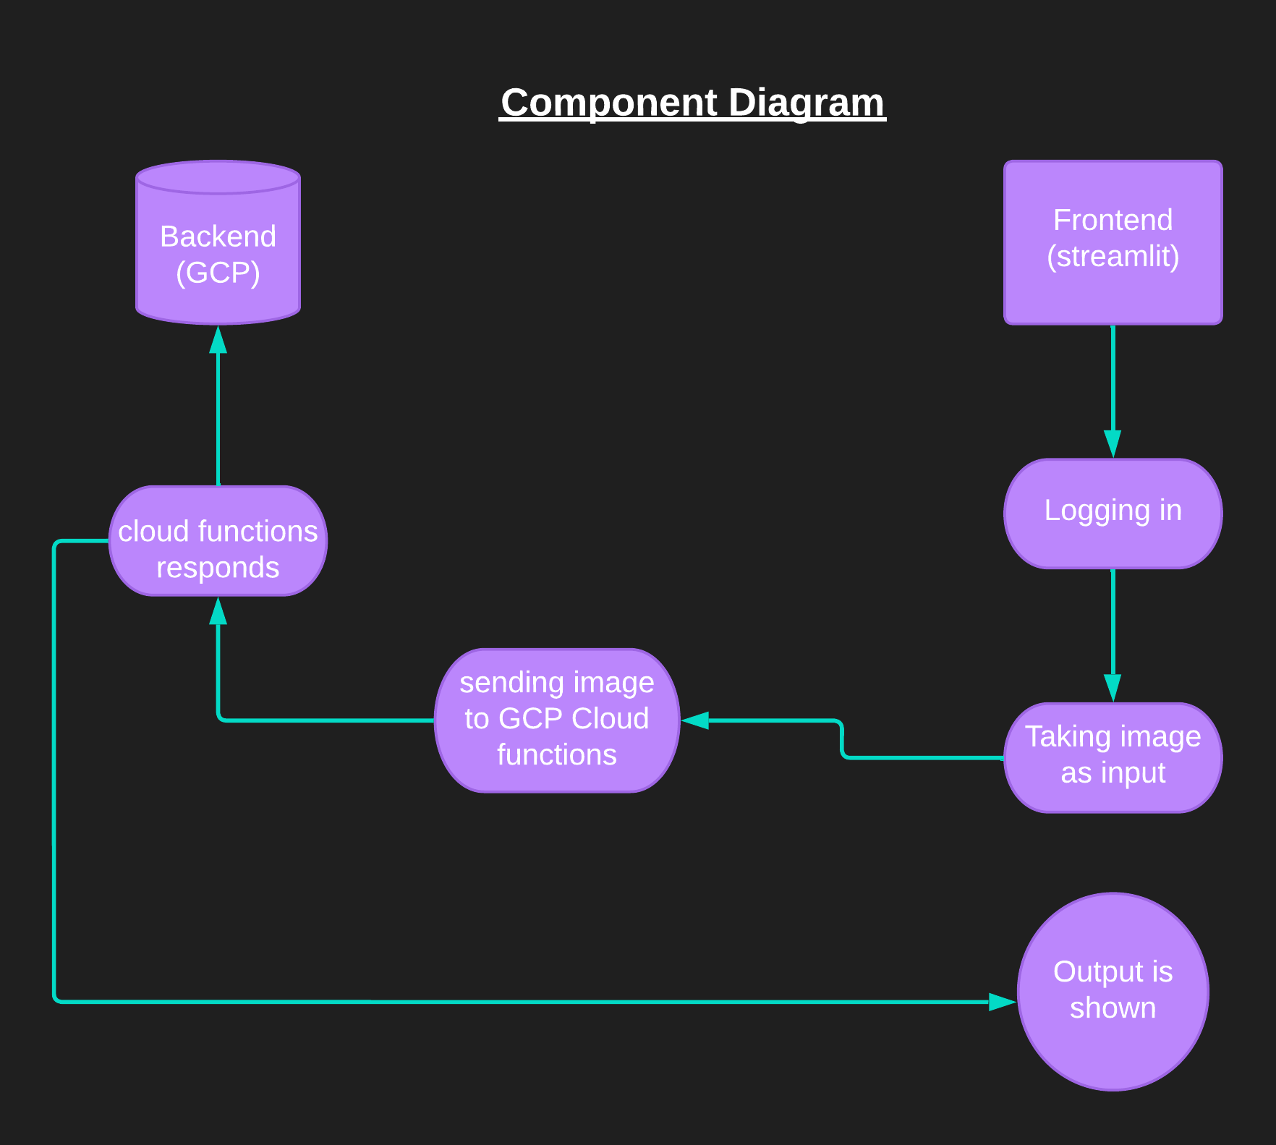

* 1. **Use Case Diagram**

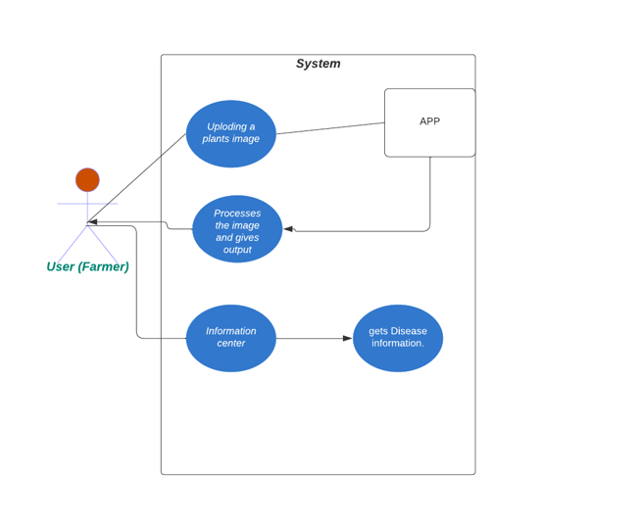

**3.5 Gantt Chart**

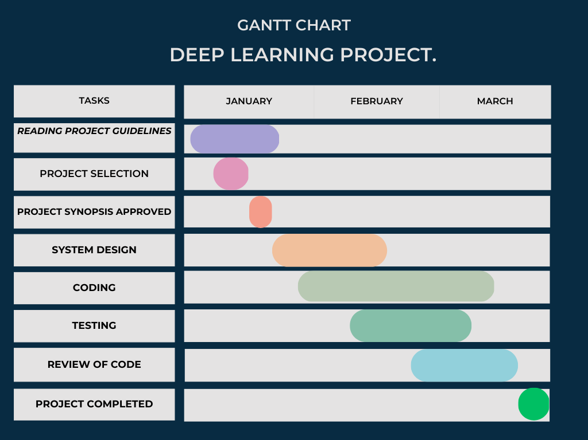

|  |  |  |
| --- | --- | --- |
| TASK | Start date | End date |
| Reading Project Guidelines | 10/01/23 | 31/01/23 |
| Project Selection | 15/01/23 | 20/01/23 |
| Creating Synopsis | 20/01/23 | 22/01/23 |
| Project Synopsis approved | 25/01/23 |  |
| System Design | 26/01/23 | 15/02/23 |
| Requirement Analysis | 16/02/23 | 17/02/23 |
| Creating a Prototype | 17/02/23 | 18/02/23 |
| Coding | 01/02/23 | 17/03/23 |
| Testing | 17/03/23 | 20/02/23 |
| 1st review of code | 28/03/23 |  |
| Worked on recommended things | 28/03/23 | 29/03/23 |
| 2nd review of code | 30/03/23 |  |
| Project completed. | 30/03/23 |  |

**CHAPTER 4**

# DATA DEFINITIONS AND FORM DESIGN/SNAPSHOTS

**4.1 Cloud Storage:**

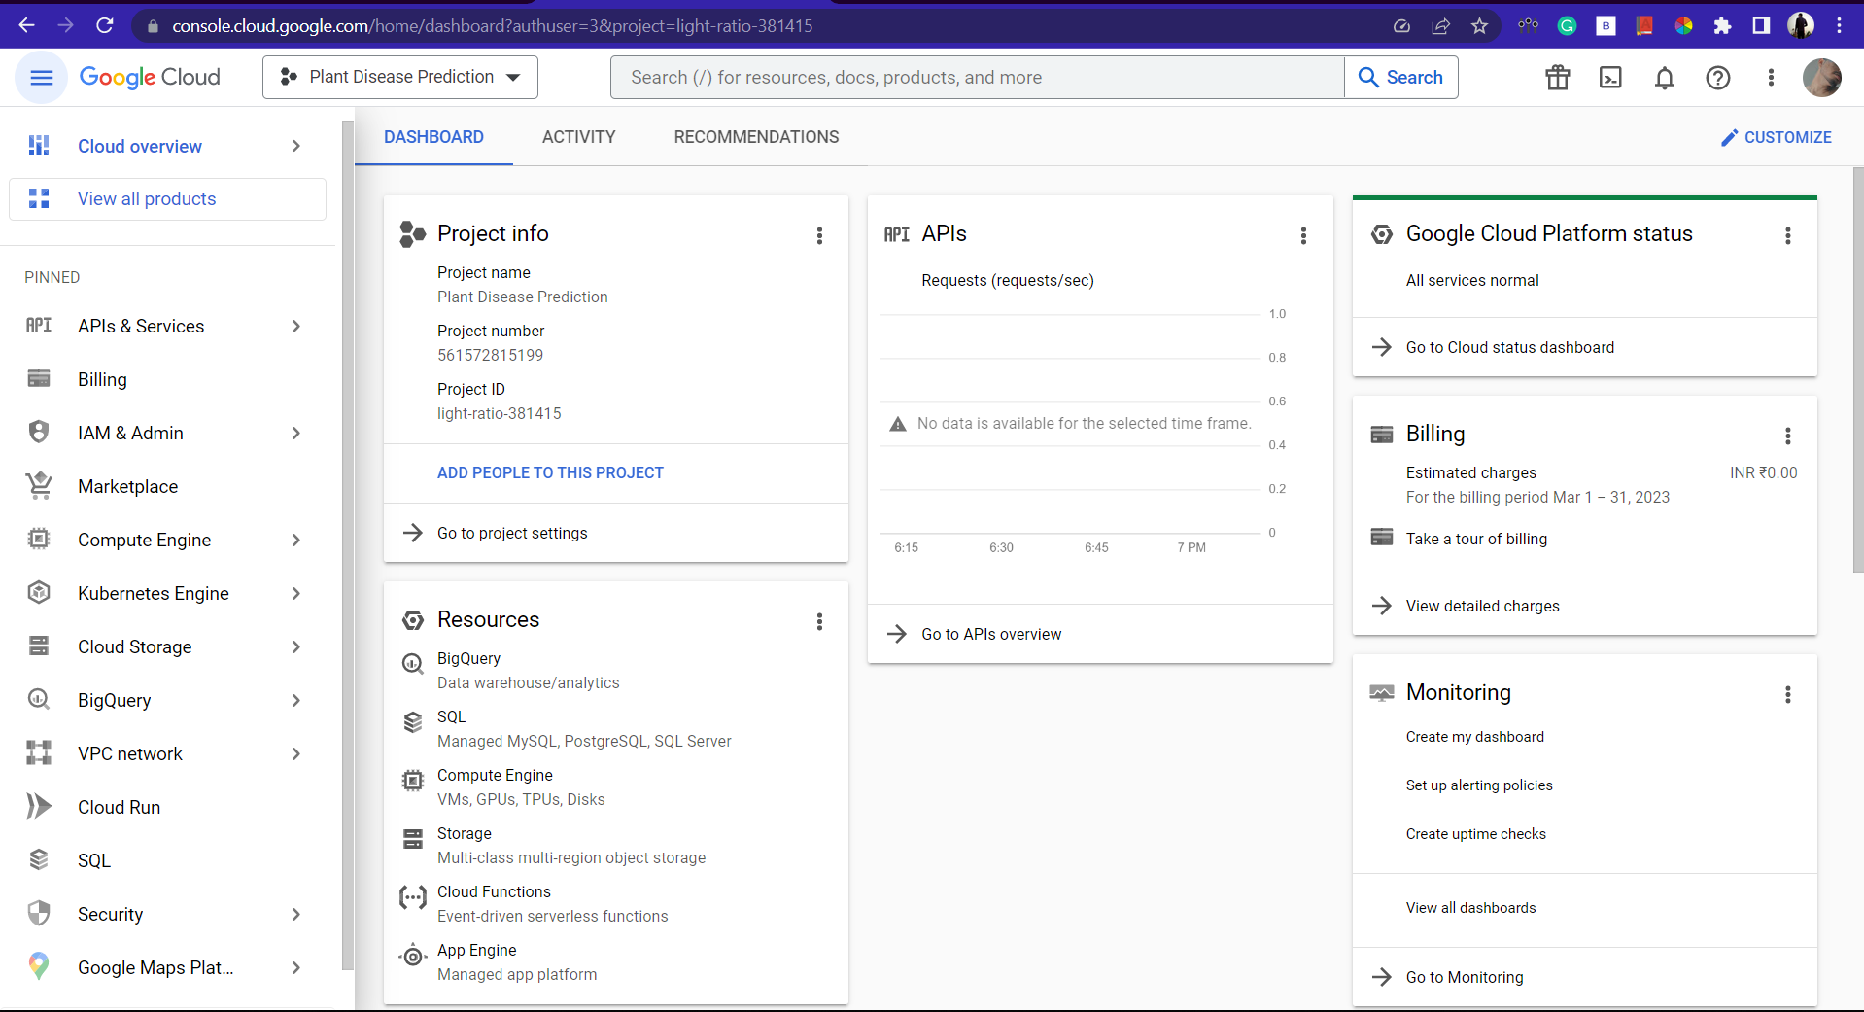

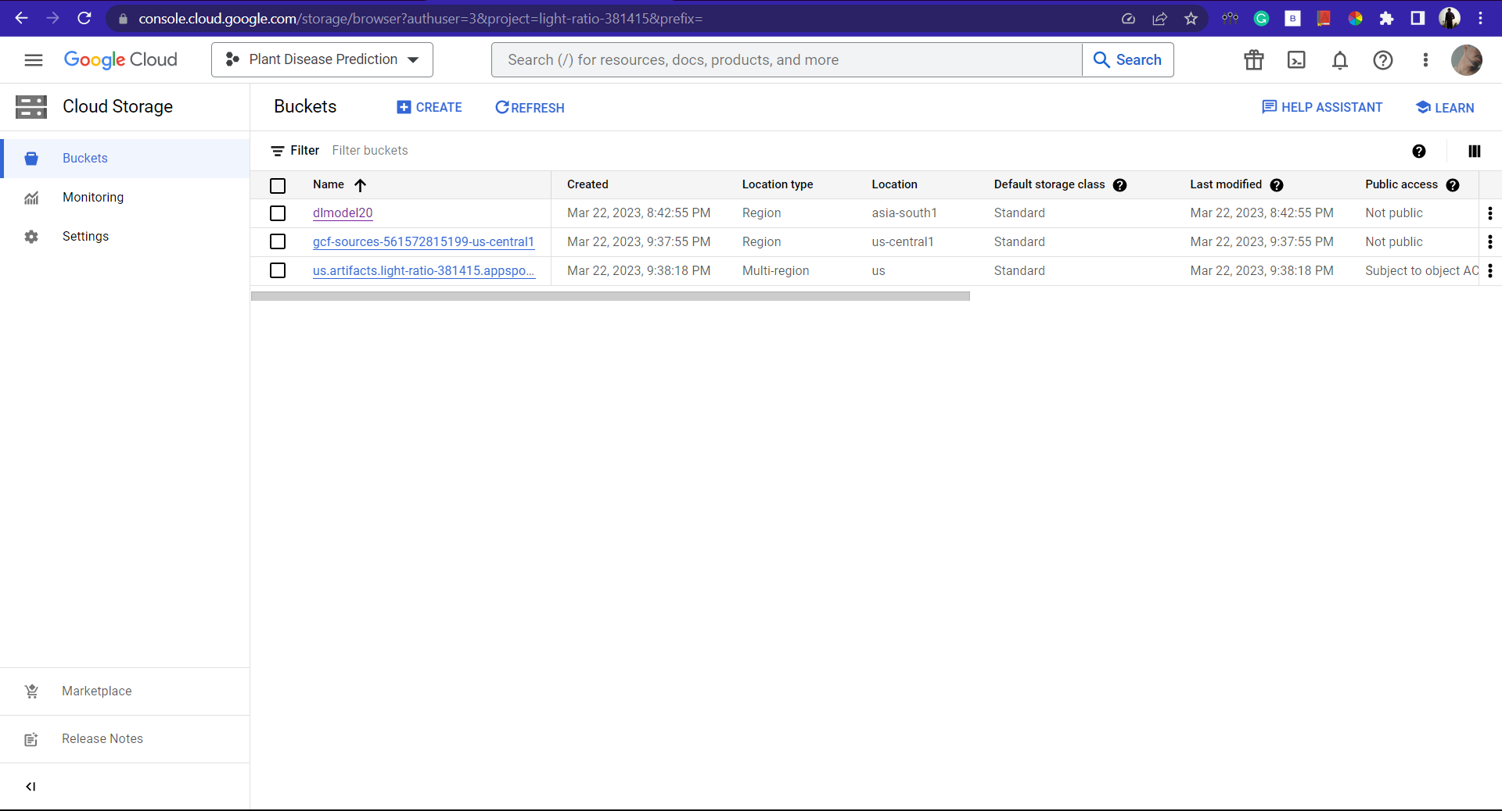

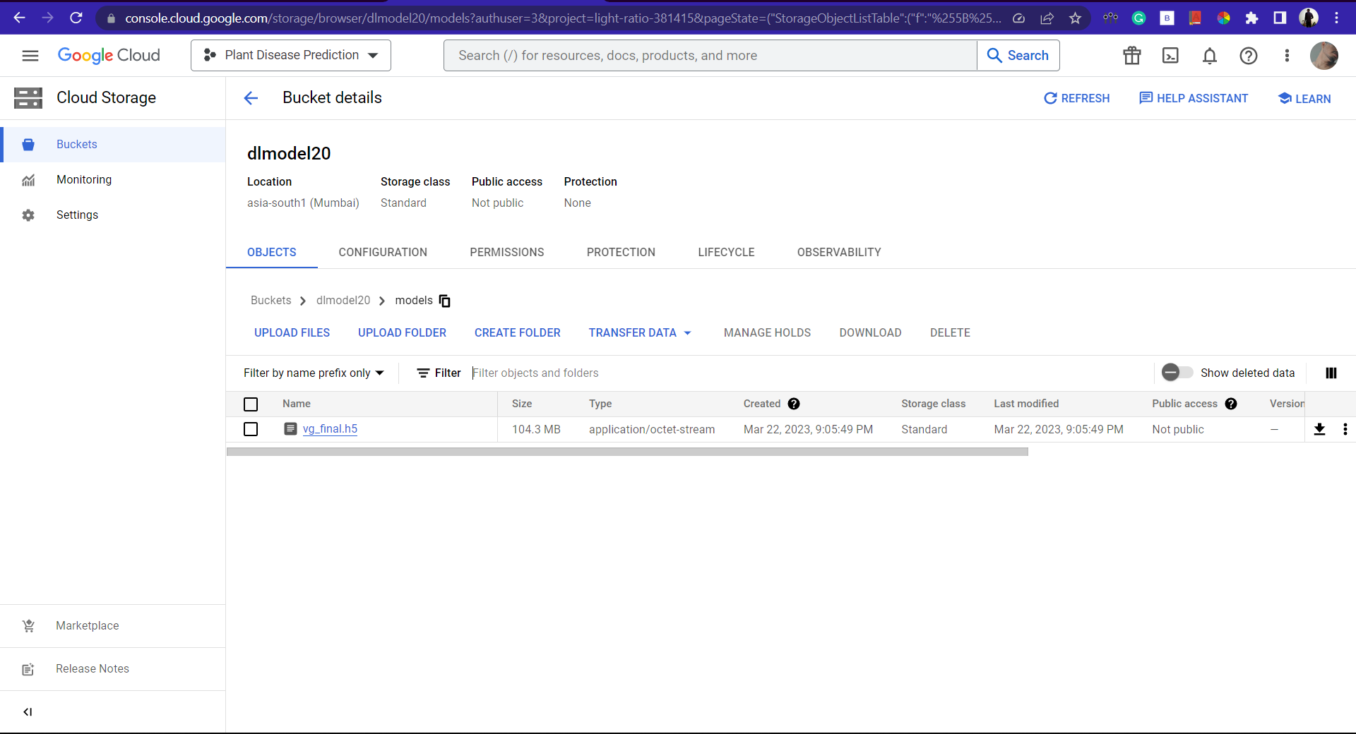

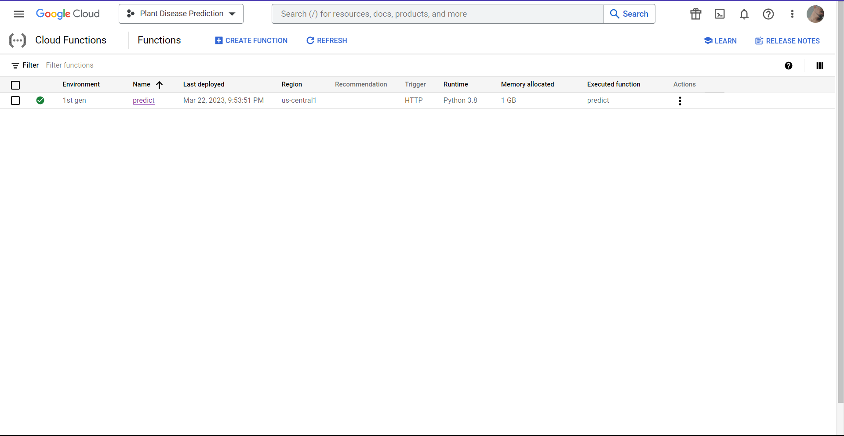

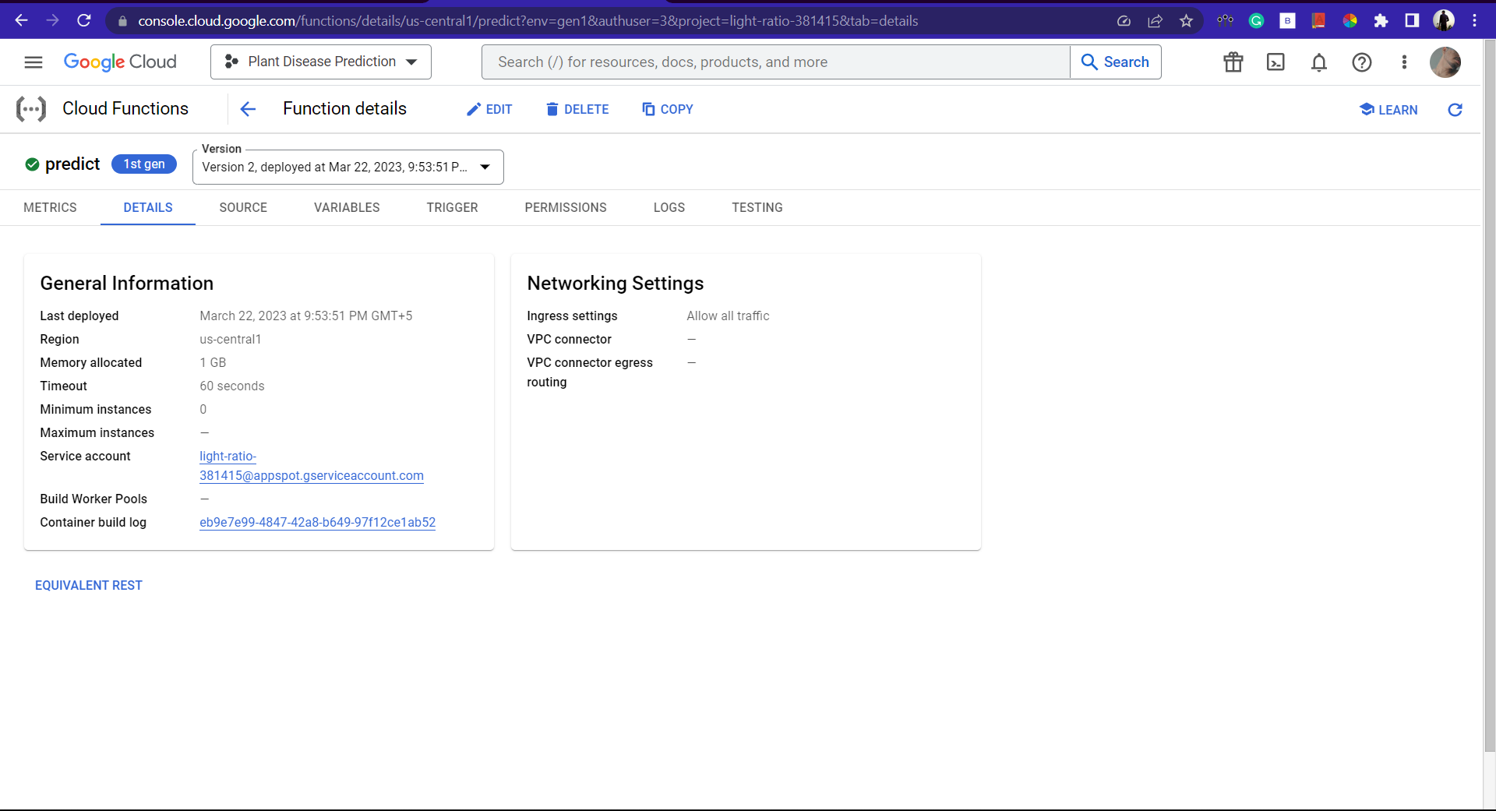

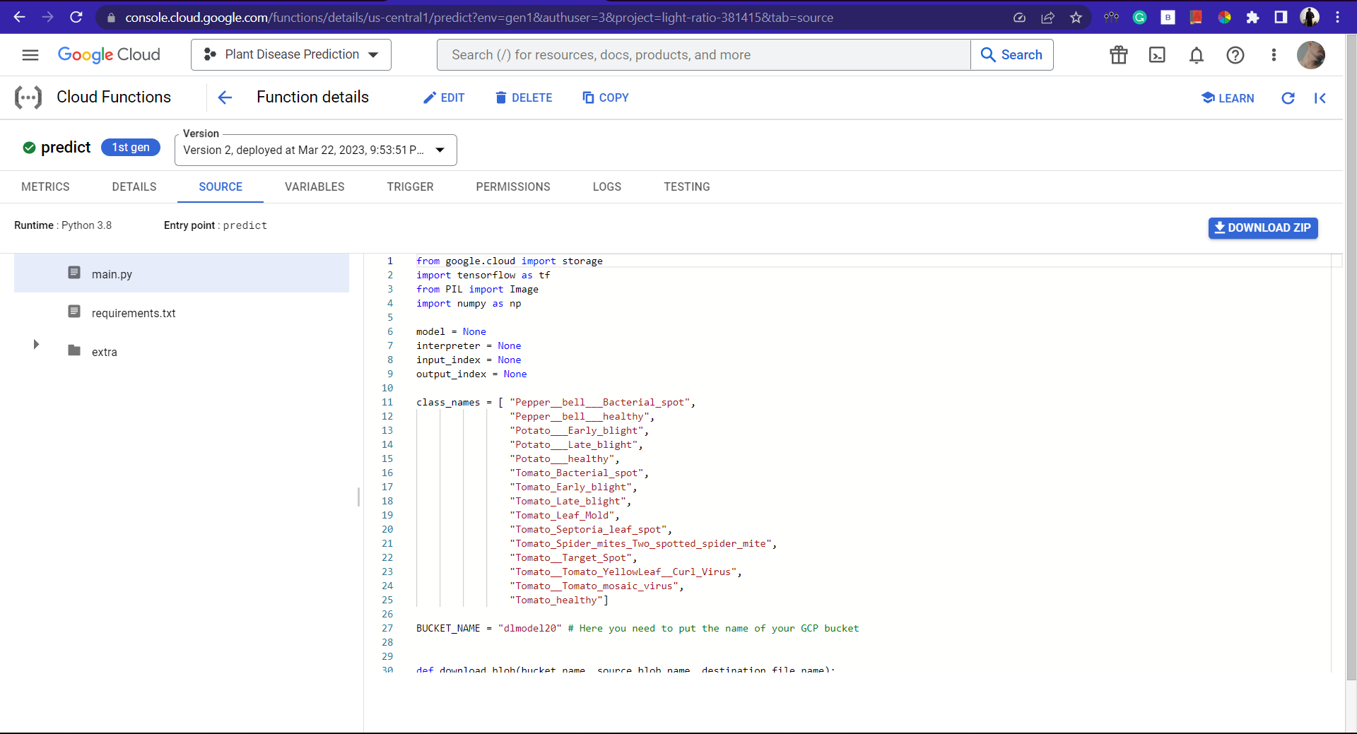

# 4.2 Form Design /Snapshots

# This section describes form those are used into the system.

# 4.2.1 React JS APP:

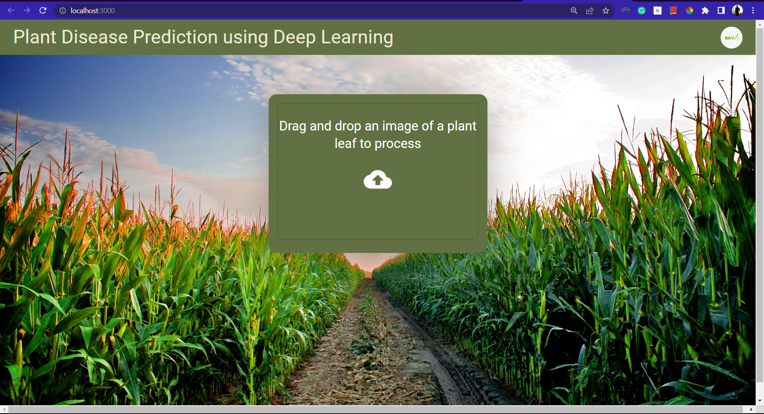

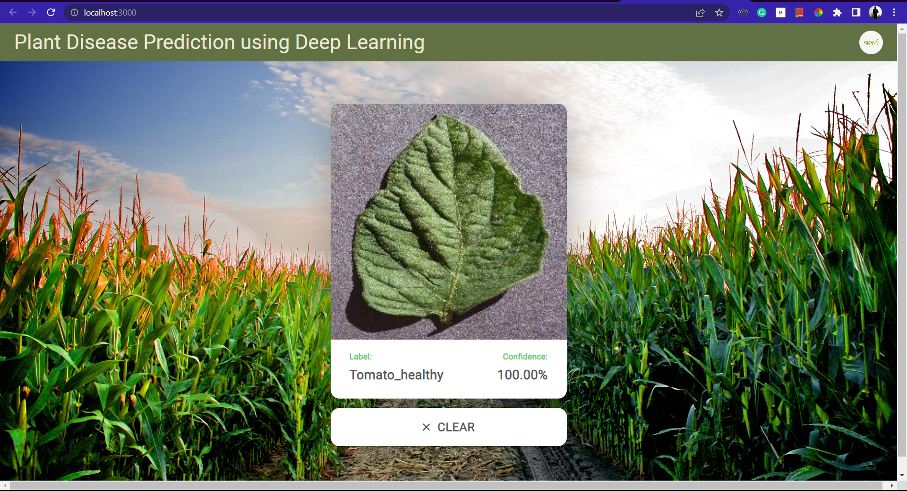

# Streamlit APP:

# Login page:

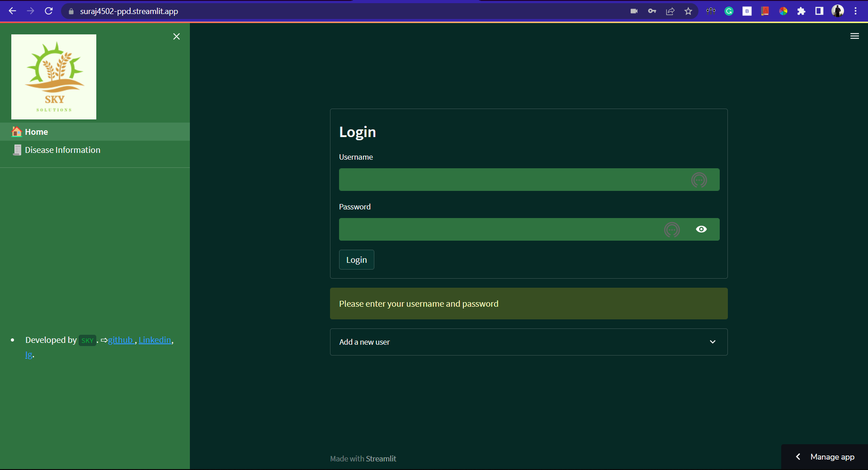

* **Signing up:**

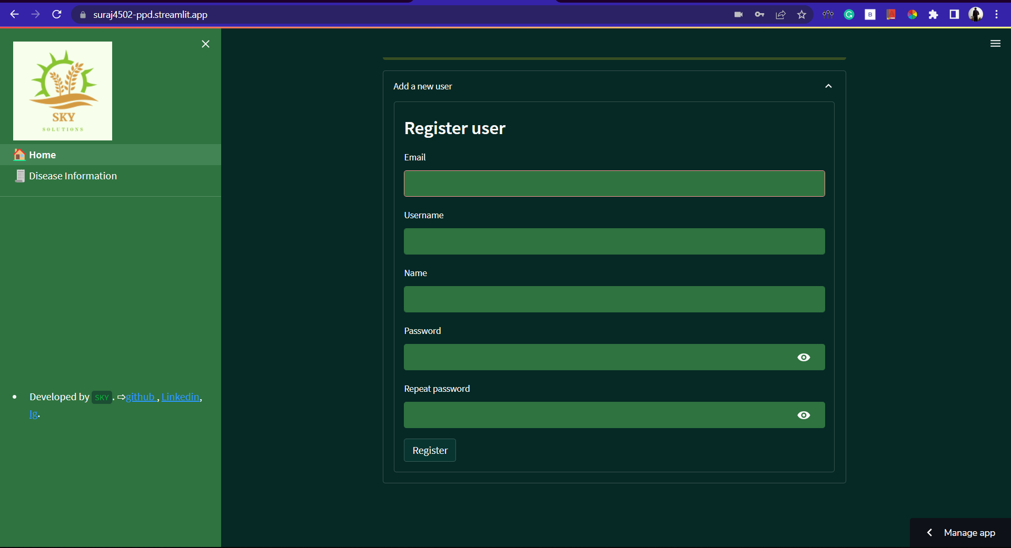

* **Retrieving Credentials:**

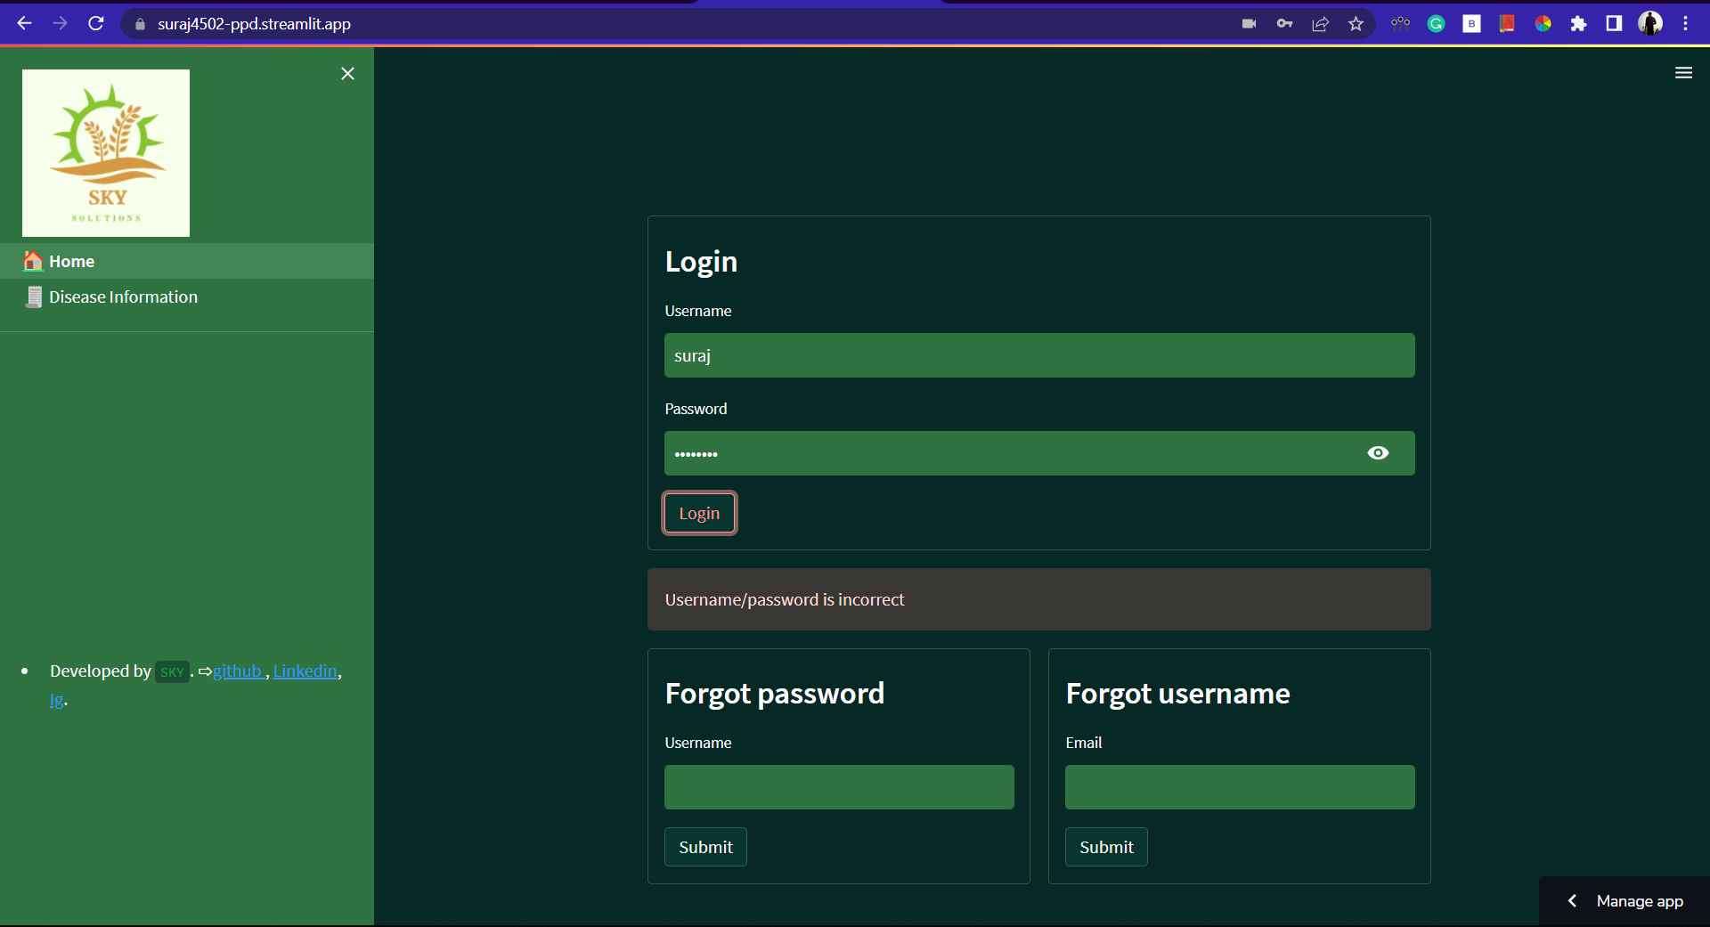

* **Main Section:**

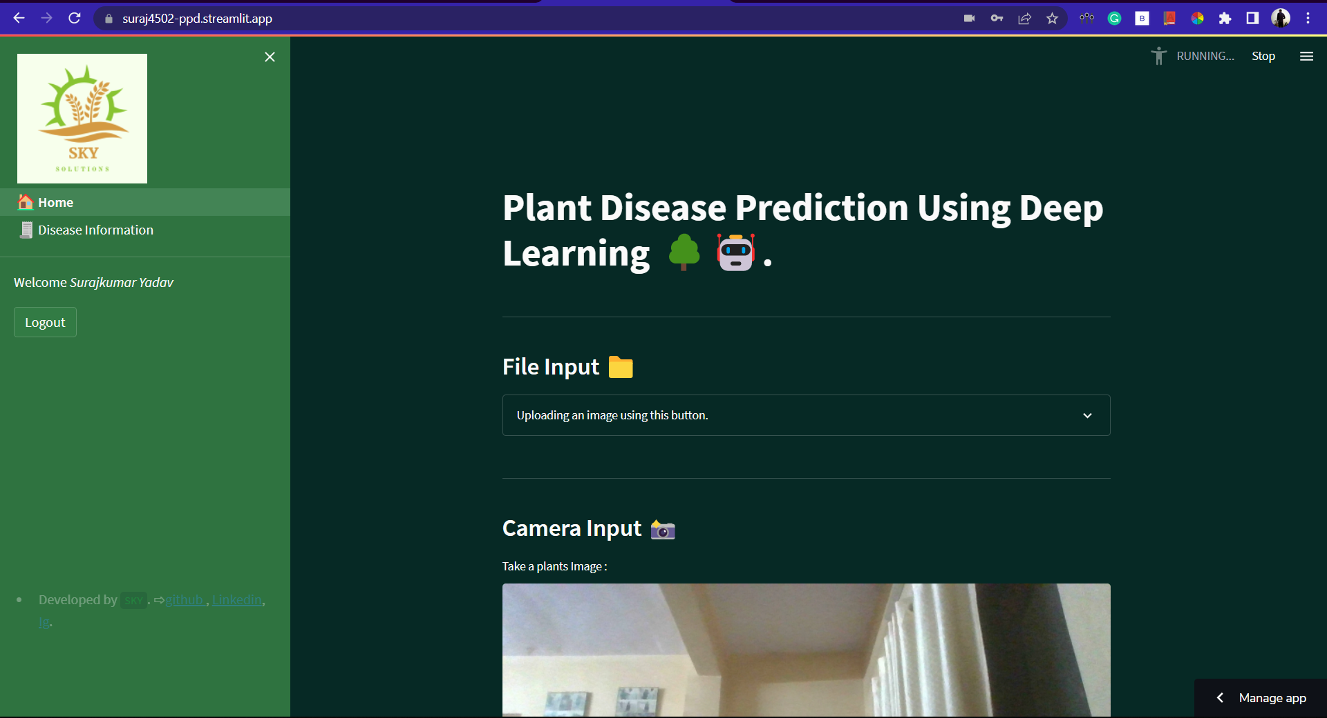

* **Uploading an image to get results:**

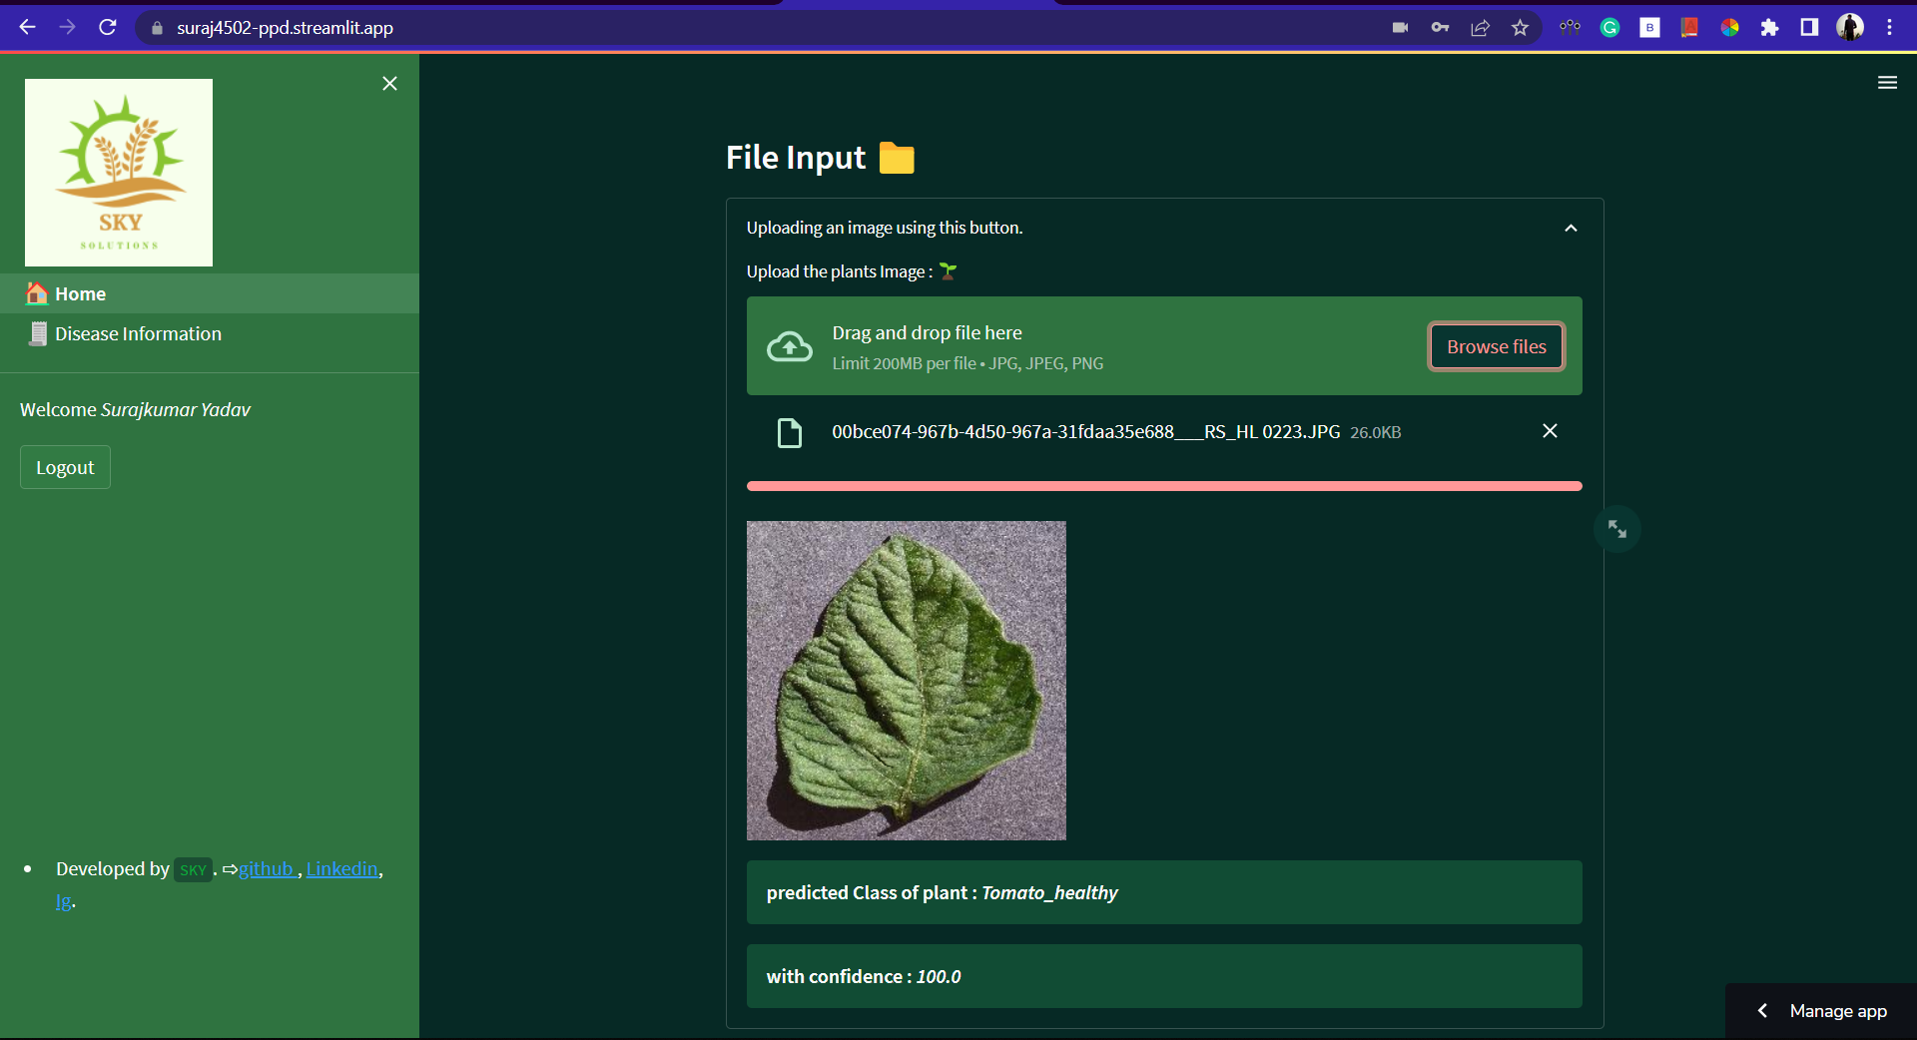

* **Taking an image from camera to get results:**

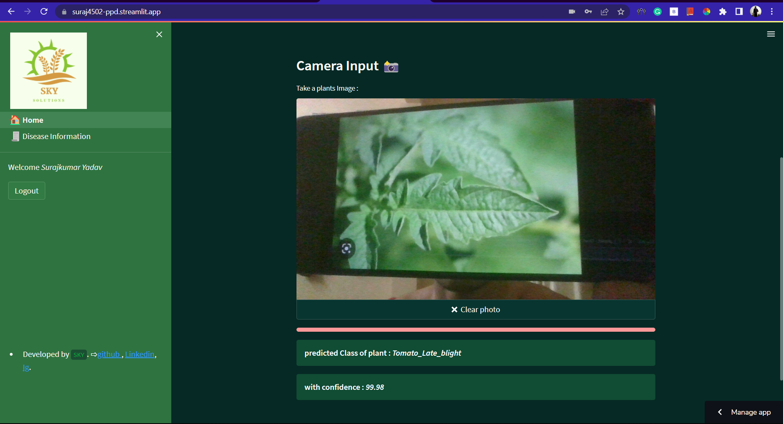

* **Disease Information Page:**

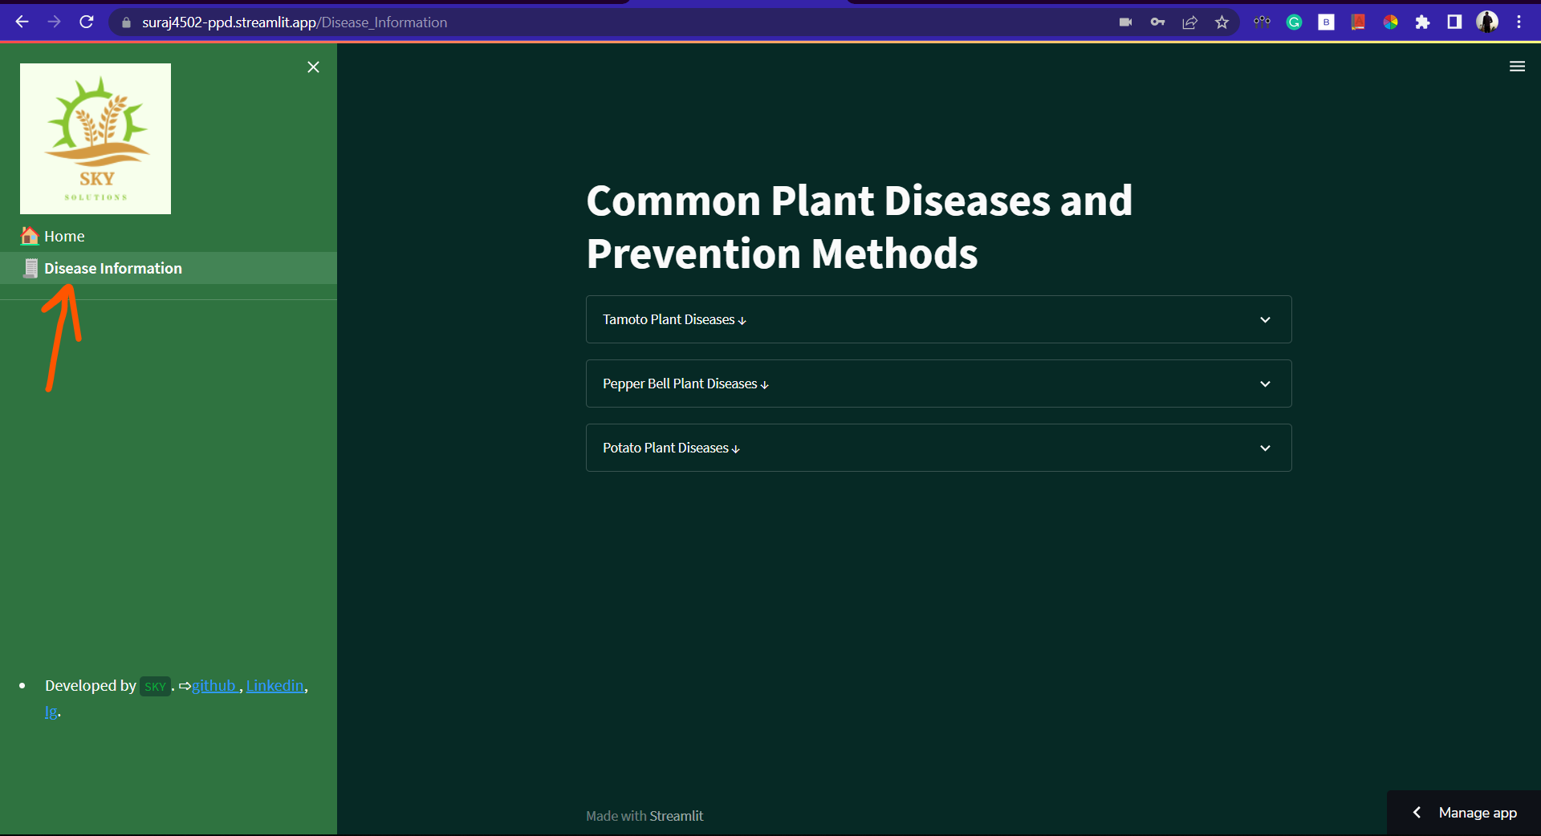

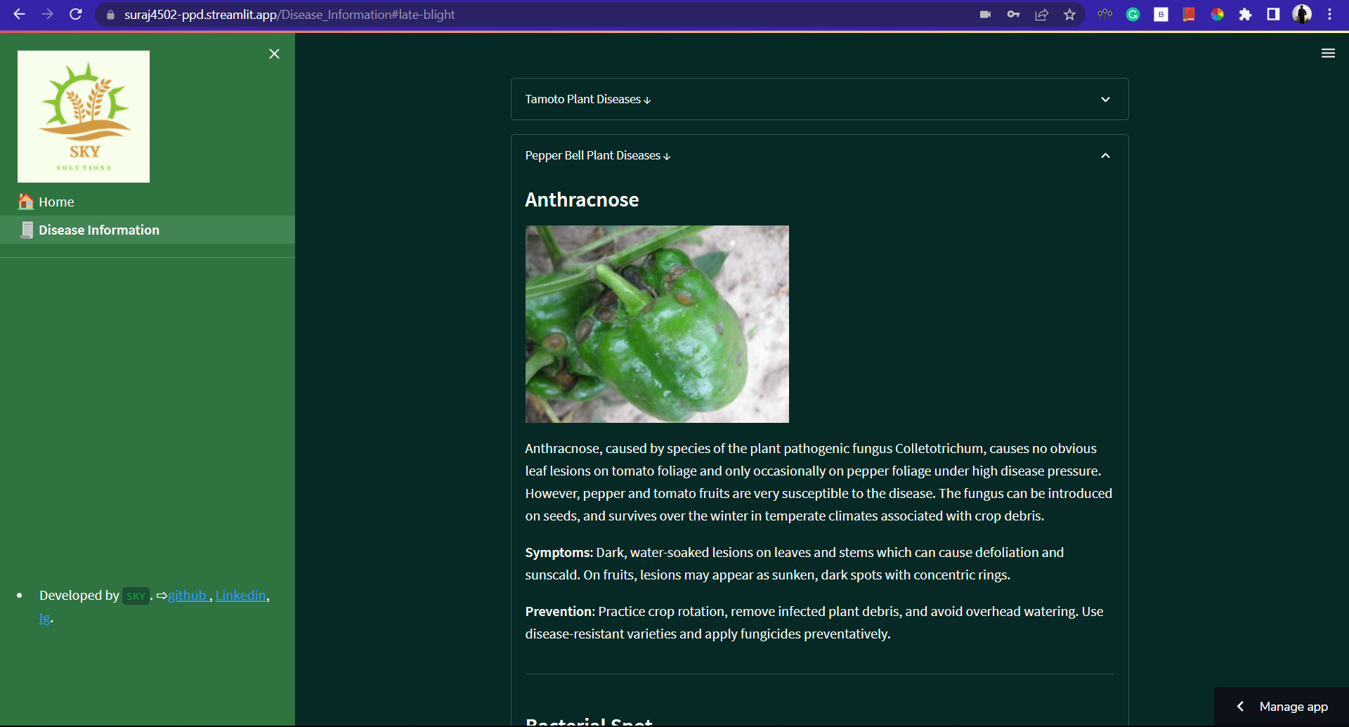

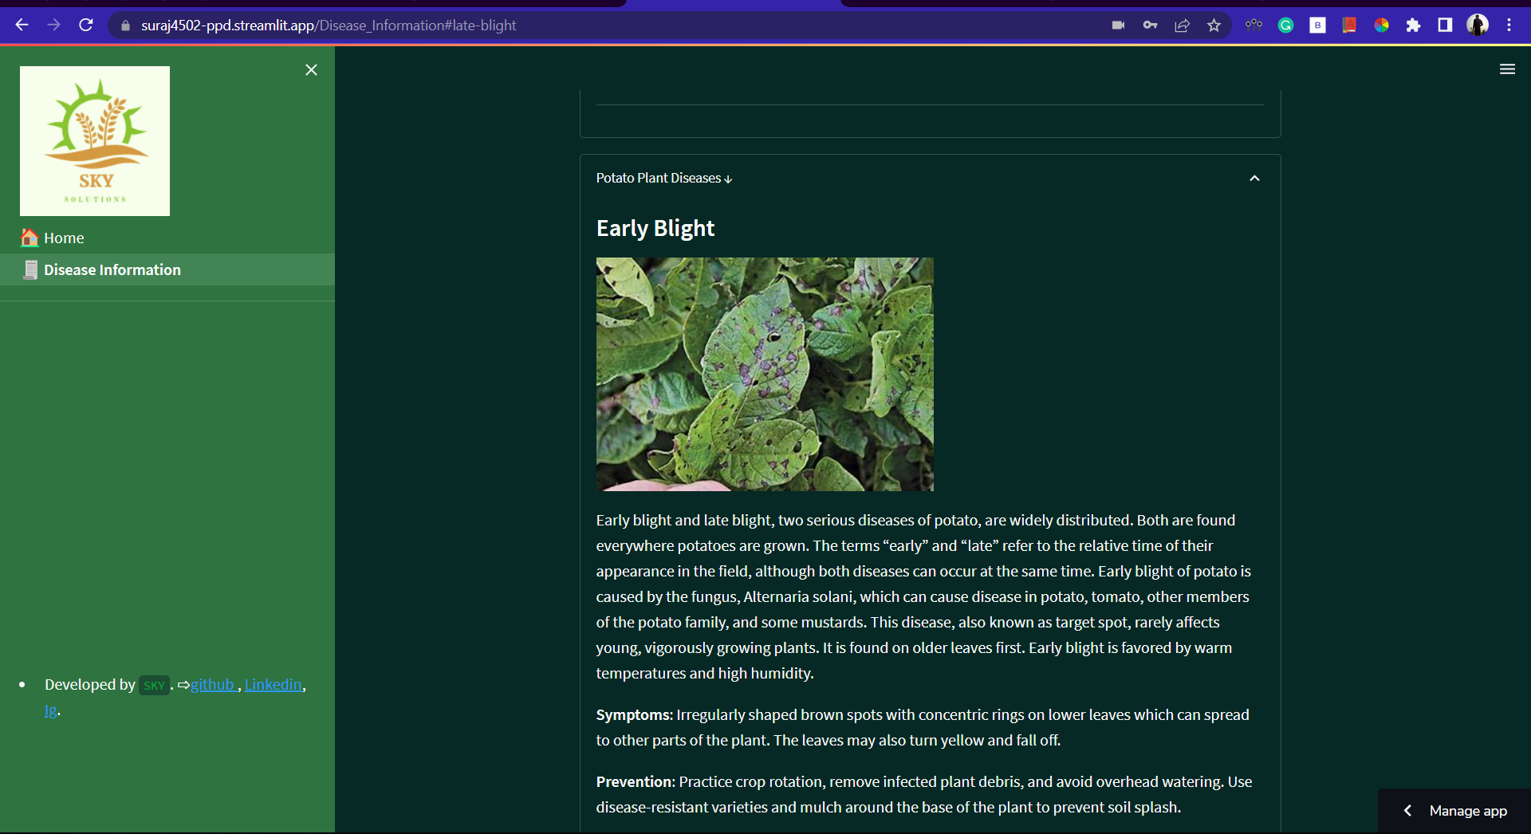

**● Mobile View:**

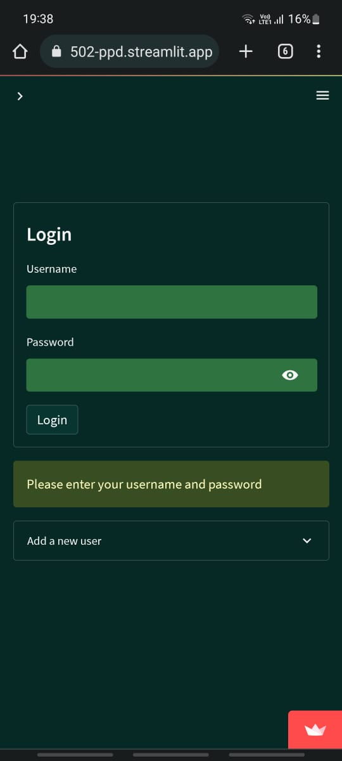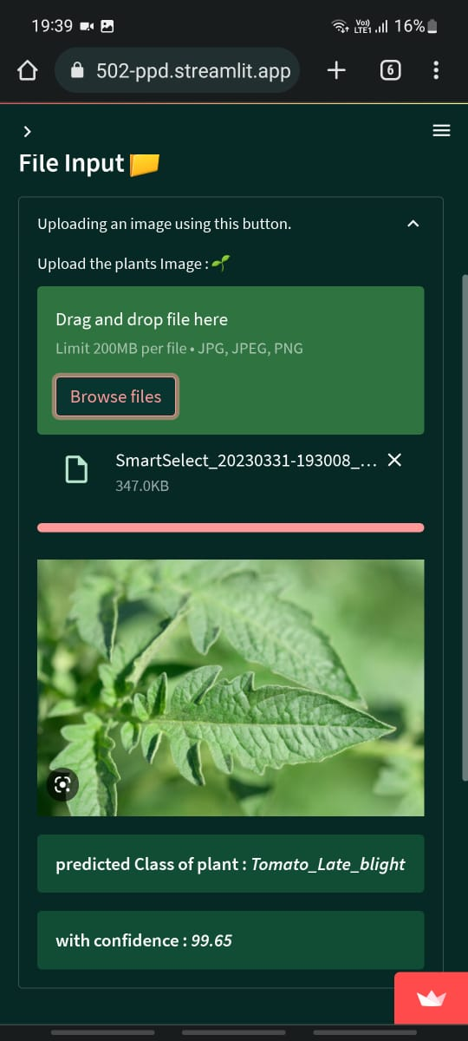

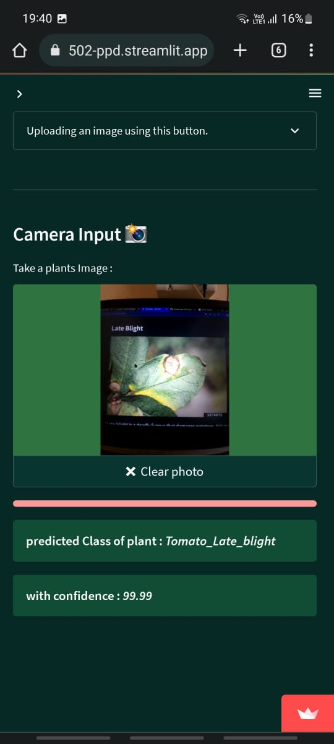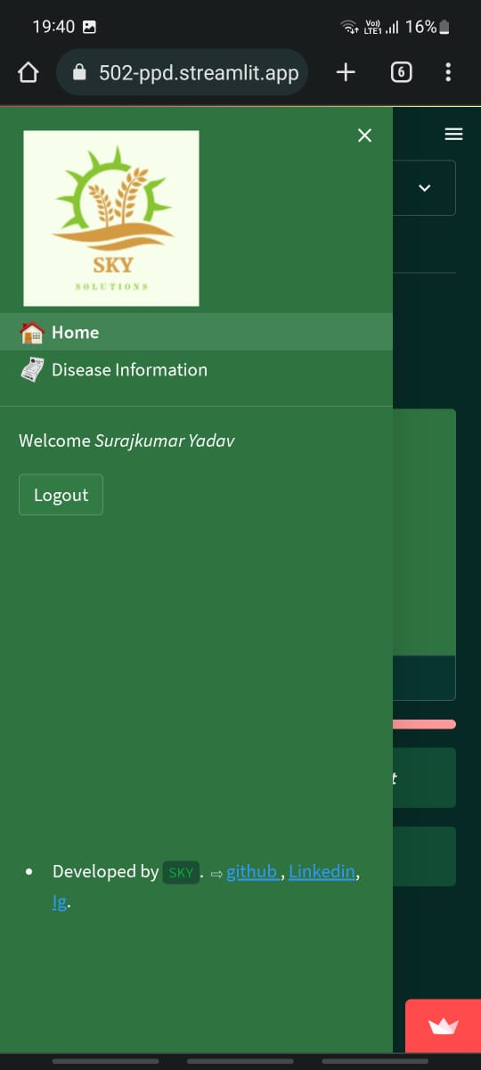

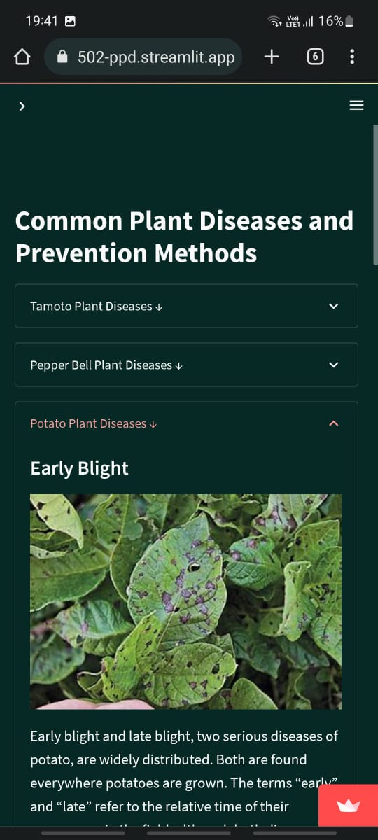

# CHAPTER 5

# SYSTEM CODE & FUTURE SCOPE

**5.1 React JS app:**

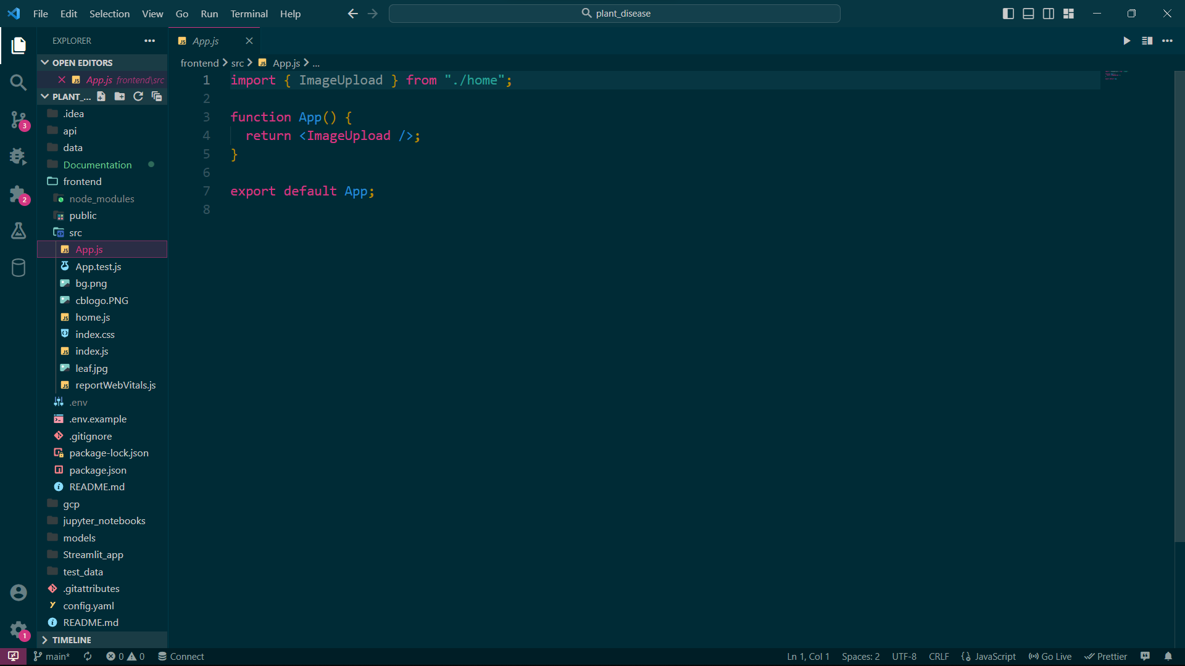

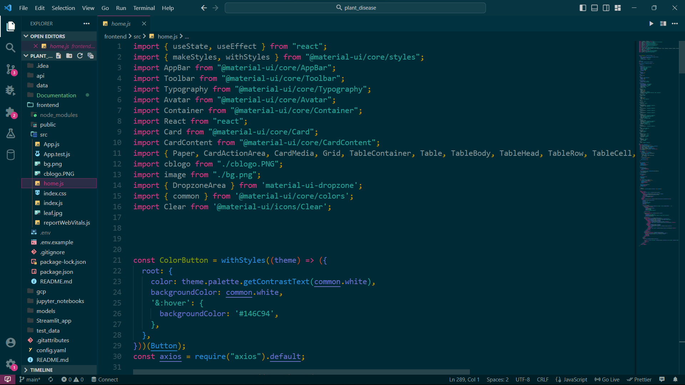

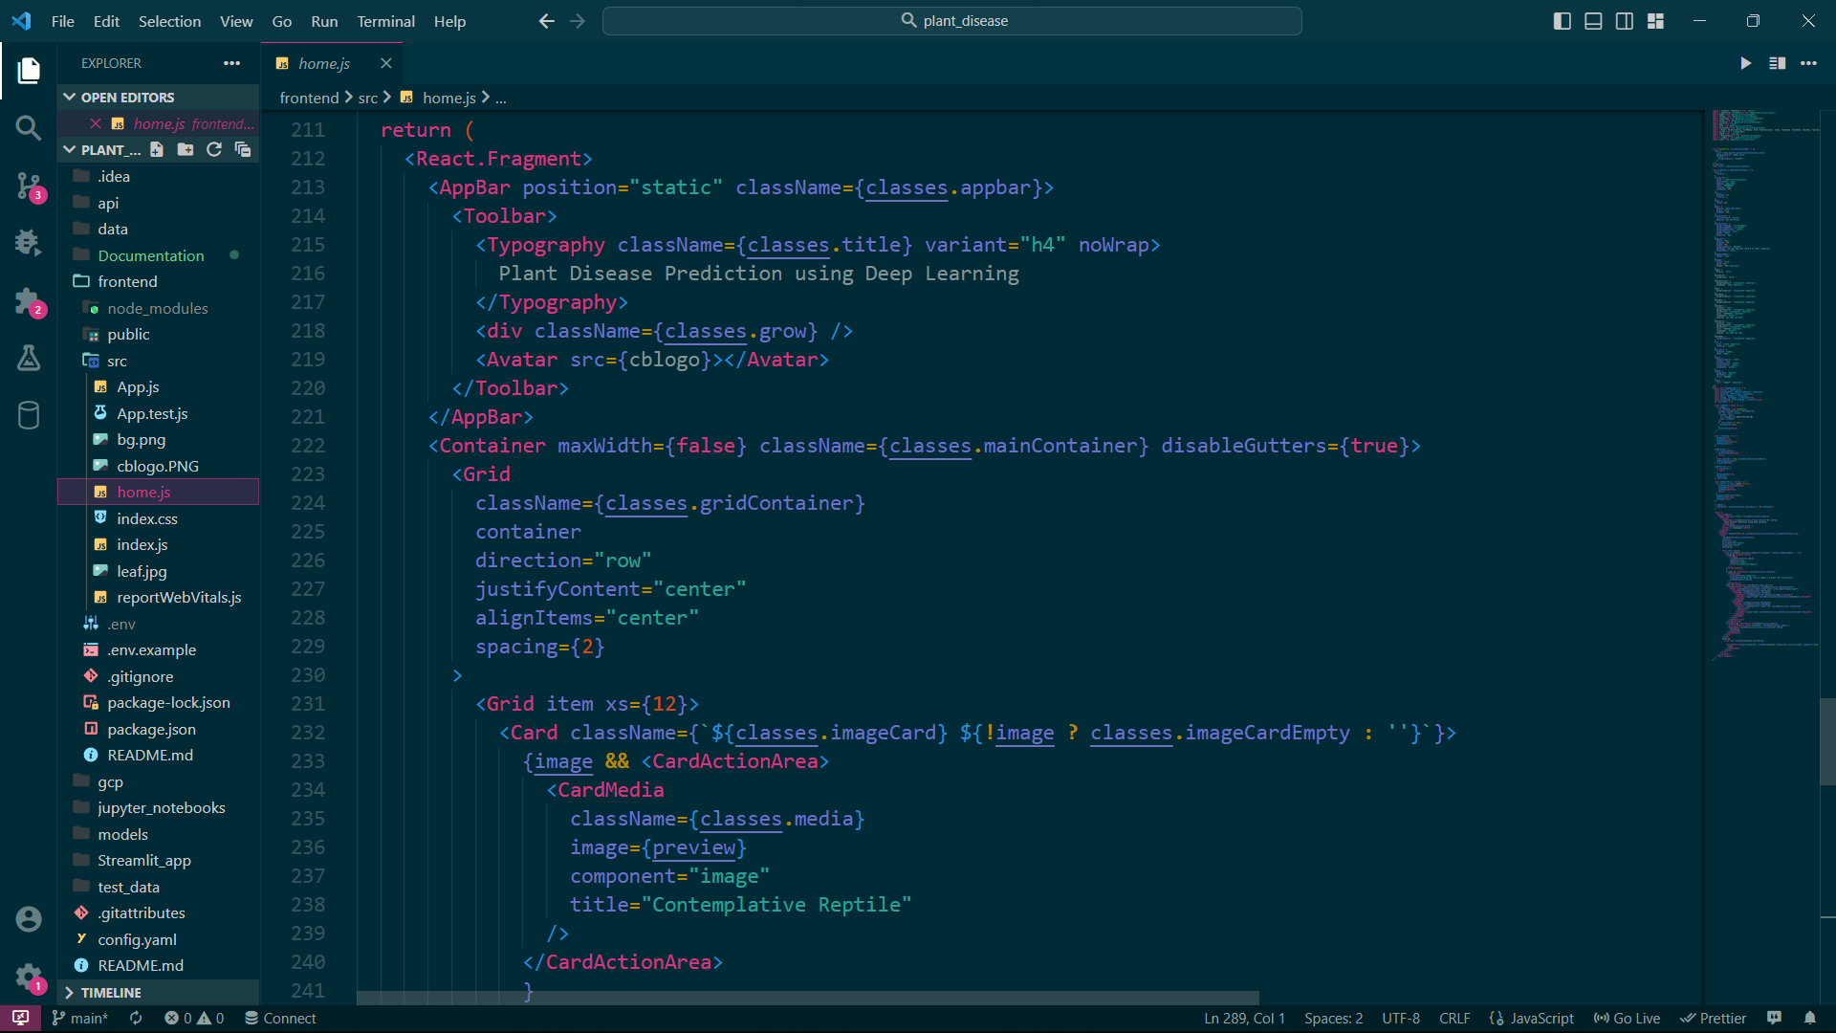

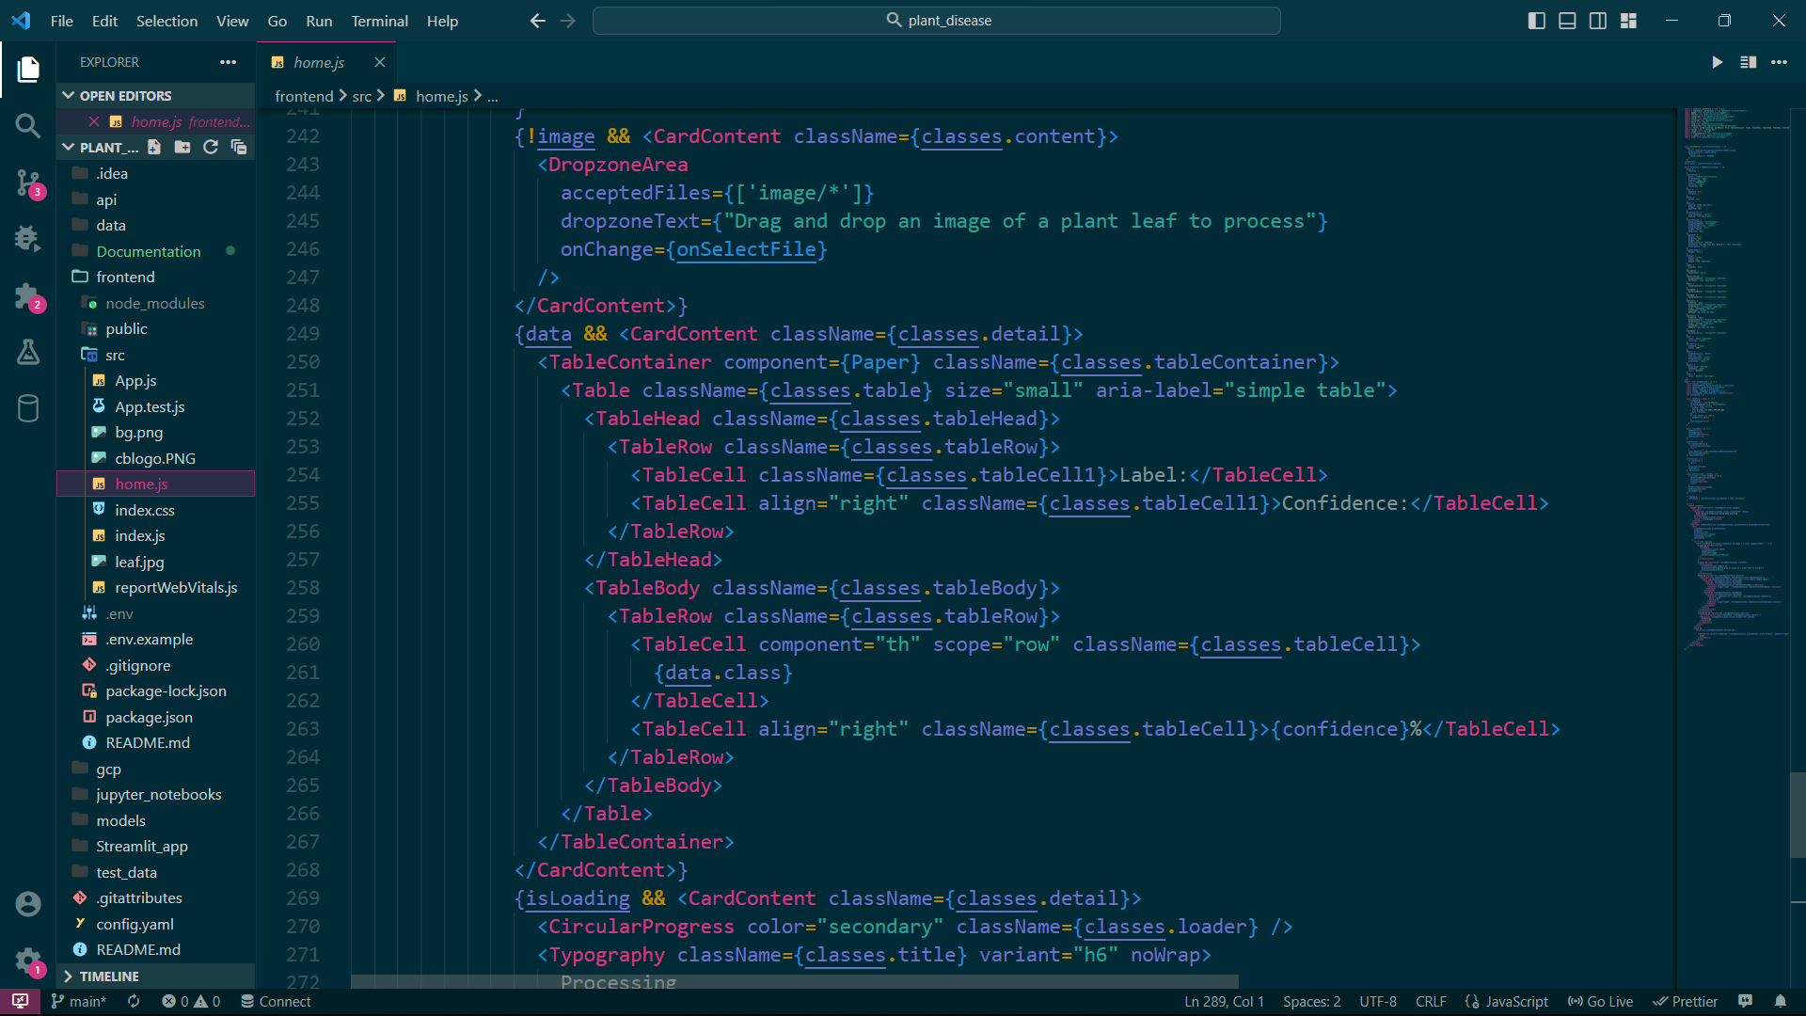

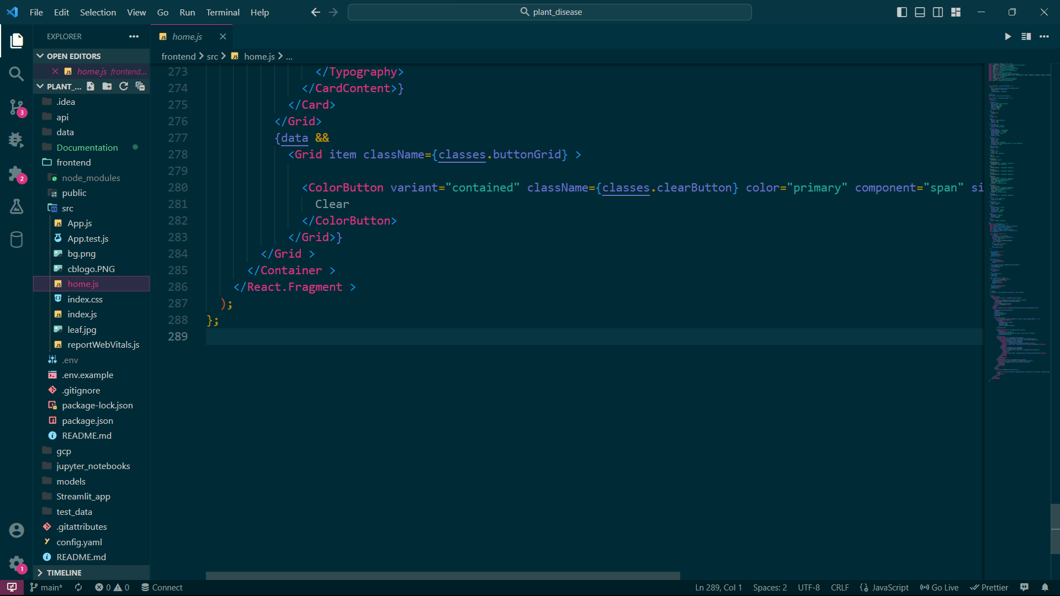

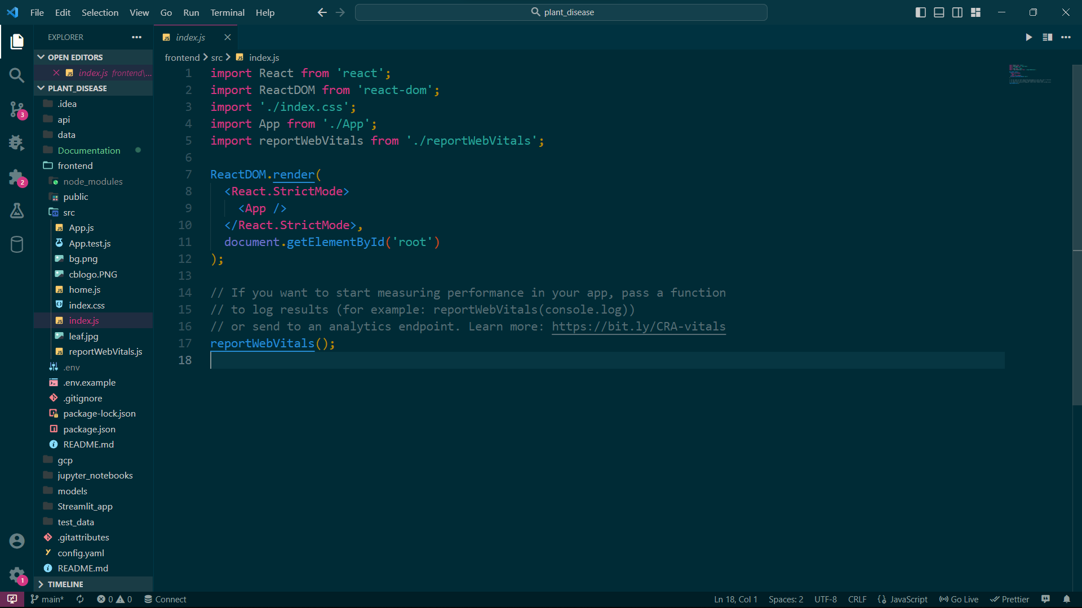

**5.2 Backend code (Fast API):**

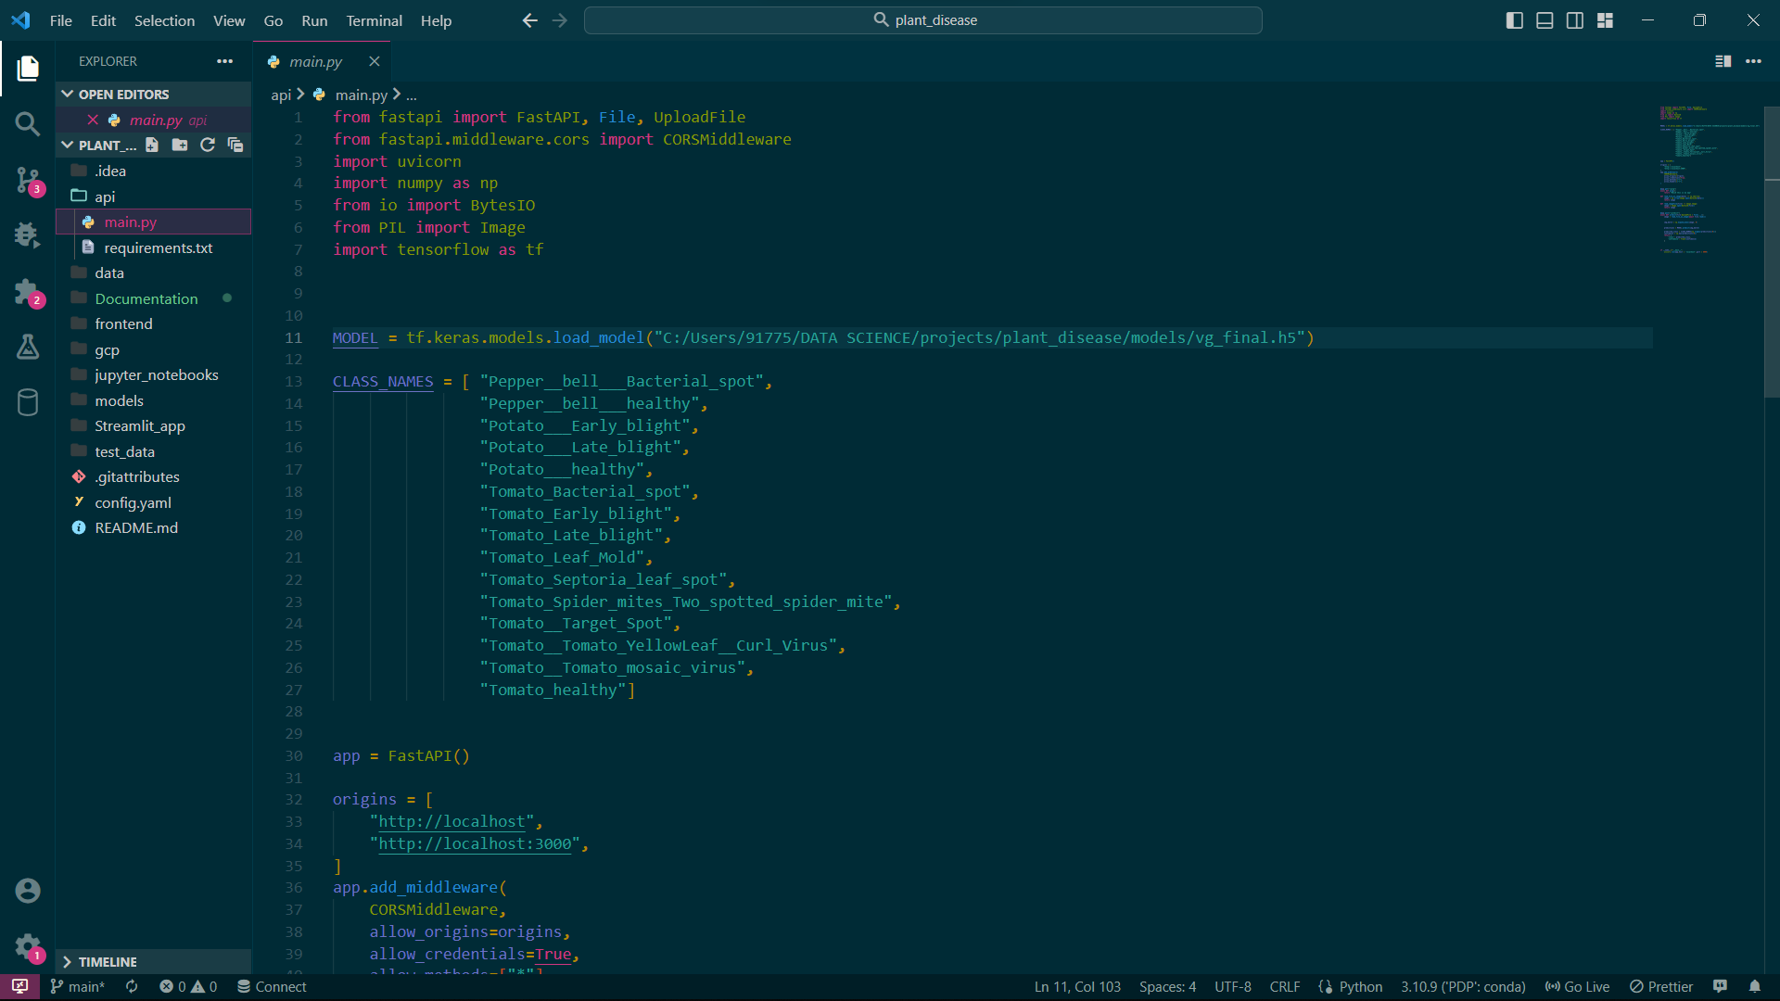

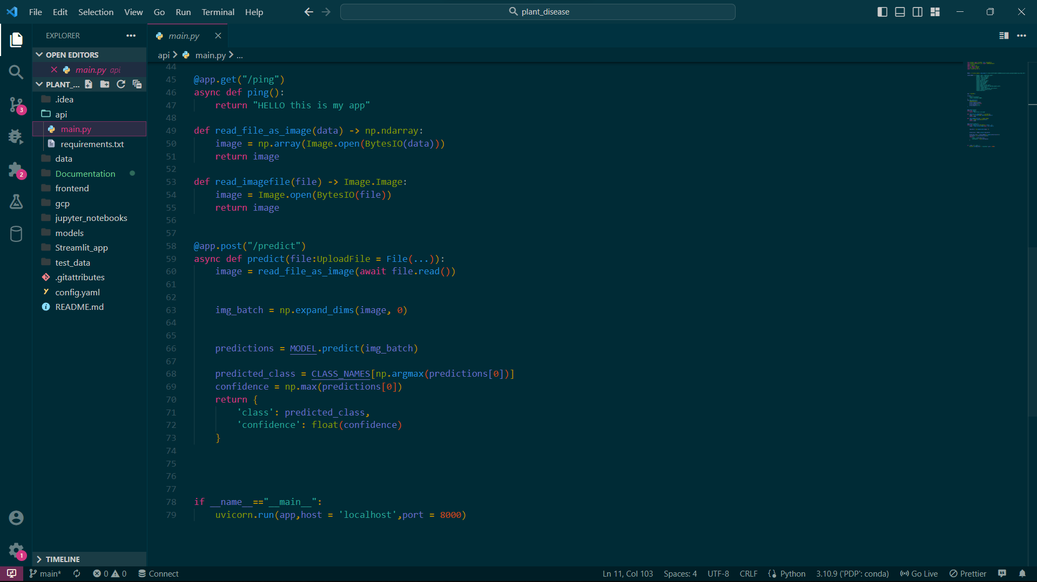

**5.3 Streamlit App :**

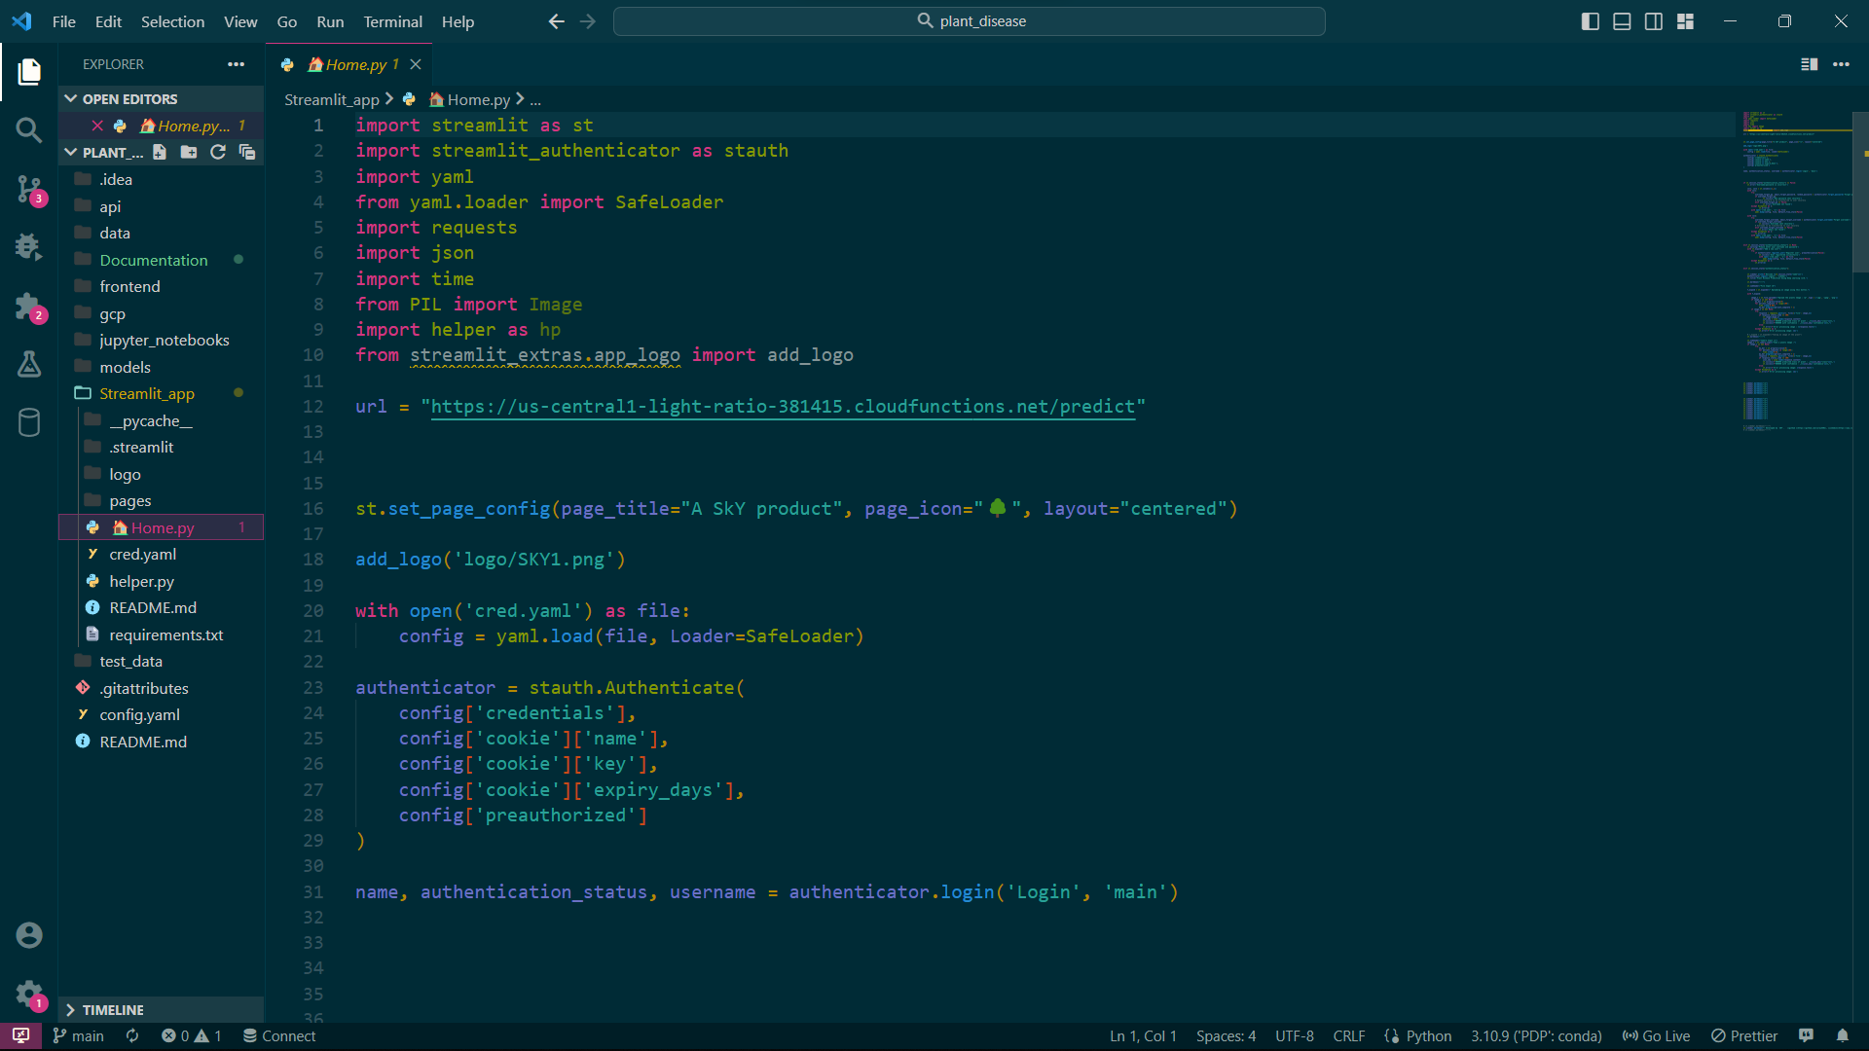

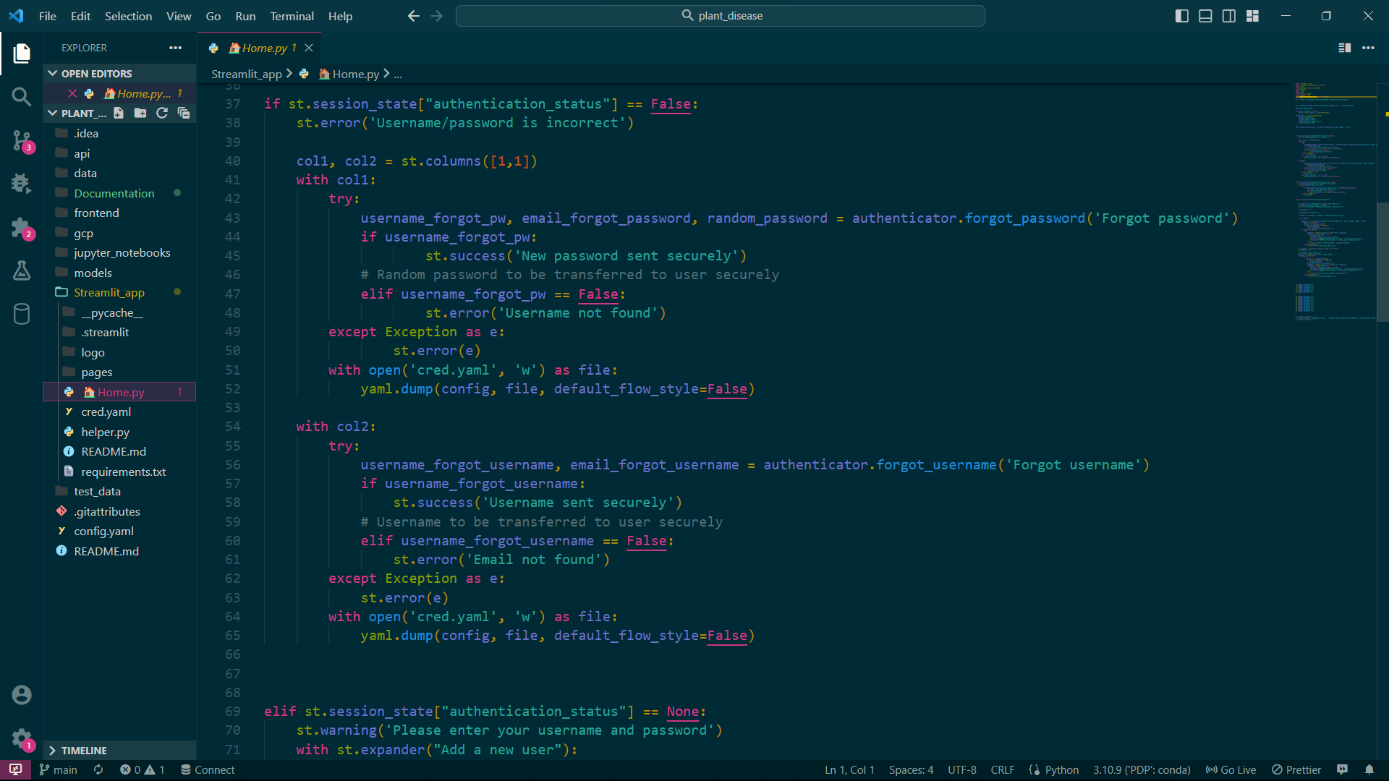

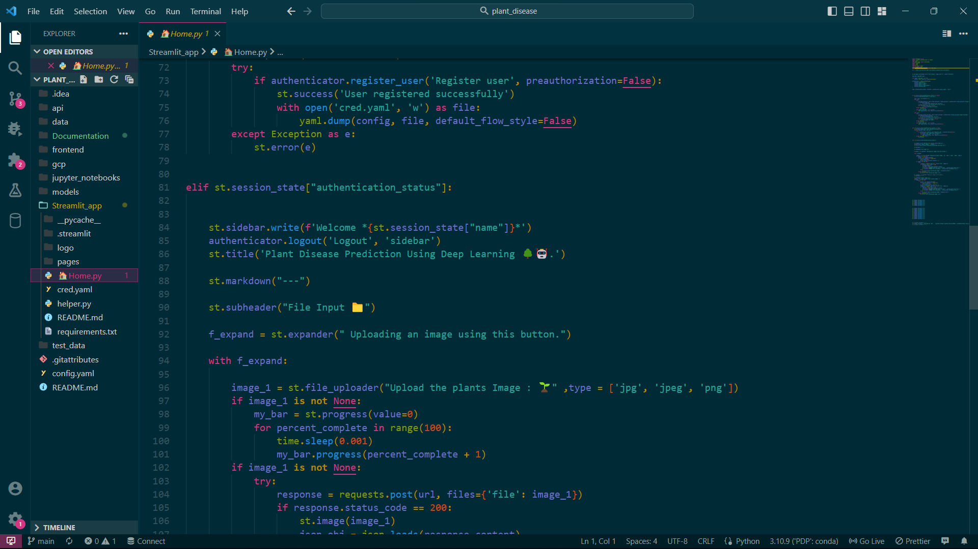

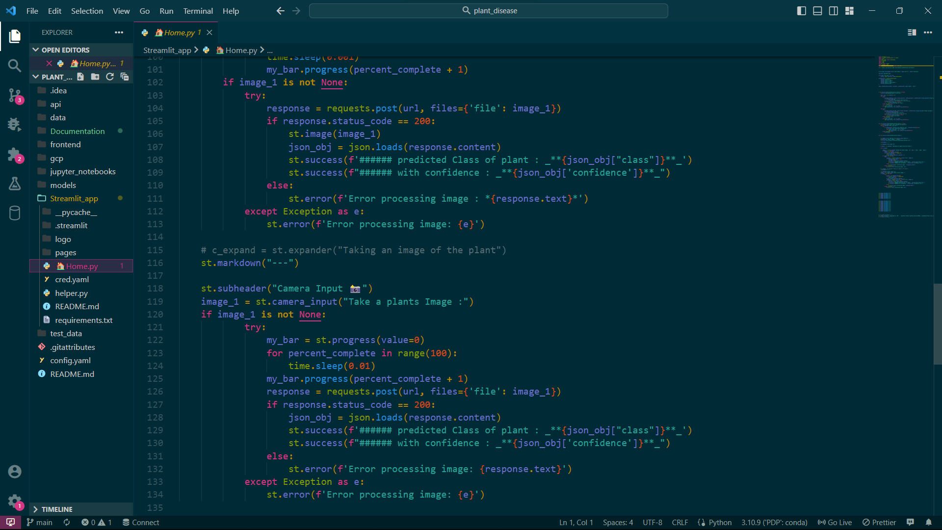

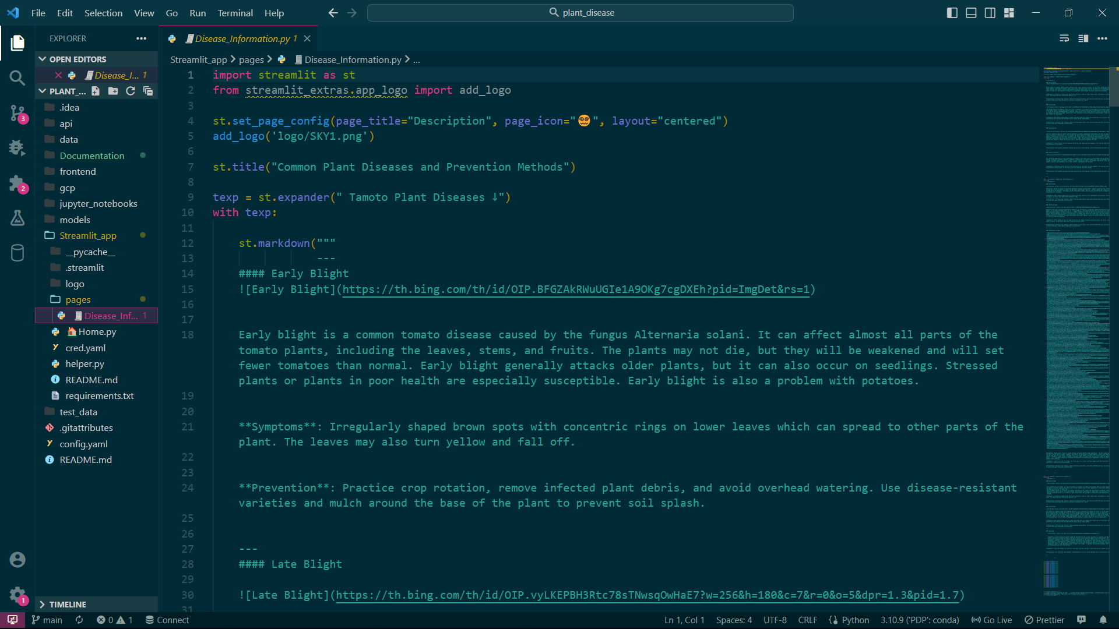

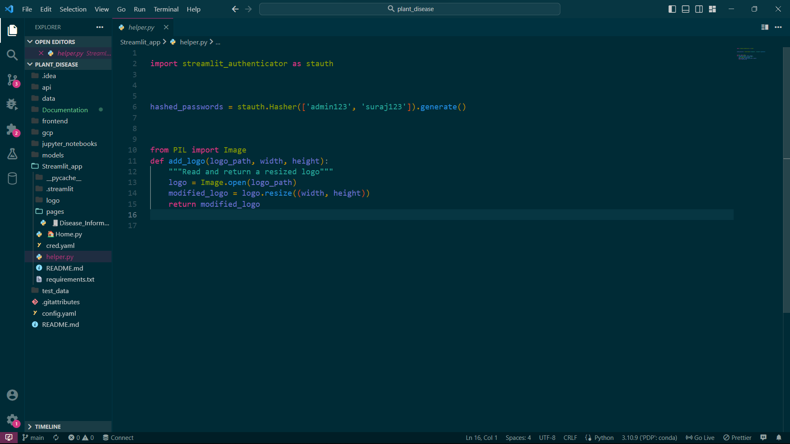

**5.8 Limitations.**

While the Plant Disease Prediction using Deep learning project has the potential to be highly beneficial, there are some limitations and challenges that need to be considered. Here are some limitations of this project:

* **Limited dataset:** Deep learning models require large amounts of data to be trained effectively. However, in the case of plant disease prediction, it can be challenging to obtain a sufficient amount of data for all plant species and disease types. This can limit the accuracy and generalization of the model.
* **Difficulty in labeling data:** Obtaining a large dataset is not the only challenge. The data needs to be properly labeled to train the deep learning model. The process of labeling data can be time-consuming and expensive, and errors in labeling can impact the accuracy of the model.
* **Variability in plant appearance:** Different plant species can exhibit varying appearances for the same disease type, and the appearance of a plant can be influenced by environmental factors. This can make it challenging to accurately identify the disease and train the model.
* **Model overfitting:** Deep learning models are prone to overfitting, where the model learns to recognize specific features in the training dataset that are not present in the test dataset. This can result in poor generalization performance of the model.
* **Model explainability:** Deep learning models are often referred to as "black boxes" because it can be difficult to understand how they arrive at their predictions. This can be problematic when trying to diagnose a disease and understand the underlying causes.
* **Deployment challenges:** Deploying deep learning models in the real world can be challenging due to computational requirements and compatibility with hardware and software infrastructure.

In conclusion, while the Plant Disease Prediction using Deep learning project has great potential, it is important to consider the limitations and challenges associated with the project to ensure that the results are accurate, reliable, and practical.

**5.9 Future Scope.**

The Plant Disease Prediction using Deep learning project has significant future scope as it can have a major impact on agriculture, food security, and environmental sustainability. Here are some potential future directions for this project:

* **Expansion of plant species and disease types:** Currently, this project may be limited to certain plant species and disease types due to the availability of data. However, as more data becomes available, the project can be expanded to cover a wider range of plant species and diseases, which will enhance its practicality and usefulness.
* **Integration with precision agriculture:** The use of deep learning for plant disease prediction can be integrated with precision agriculture techniques to optimize crop yields and minimize the use of fertilizers and pesticides. This can lead to more sustainable and efficient agricultural practices.
* **Real-time monitoring:** The project can be integrated with real-time monitoring systems that can continuously analyze plant health data and provide early warnings of disease outbreaks. This can enable timely interventions to prevent the spread of diseases and reduce crop losses.
* **Collaboration with plant scientists:** Collaboration with plant scientists can help to identify new features and data sources that can enhance the accuracy and robustness of the deep learning models. This can lead to the development of more advanced and reliable prediction models.

In conclusion, the Plant Disease Prediction using Deep learning project has significant future scope in agriculture and environmental sustainability. With continued research and development, this project has the potential to revolutionize the way we detect, diagnose, and manage plant diseases.

**References.**

* Articles:

<https://www.analyticsvidhya.com/blog/2021/10/understanding-transfer-learning-for-deep-learning/>

<https://www.researchgate.net/publication/360397084_Plant_Disease_Detection_Using_Cnn>

* Youtubers:

[Misra Turp](https://www.youtube.com/c/Soyouwanttobeadatascientist)

[CodingIsFun](https://www.youtube.com/c/CodingIsFun)

[Avra](https://www.youtube.com/c/Avra_b)

[krishnaik](https://www.youtube.com/user/krishnaik06)

[Fanilo Andrianasolo](https://www.youtube.com/c/FaniloAndrianasolo)

* Other Refernces :

<https://docs.streamlit.io/library/api-reference>

<https://docs.python.org/3/>

<https://towardsdatascience.com/how-to-add-a-user-authentication-service-in-streamlit-a8b93bf02031>